Press release
Bespoke creations - Art and Furniture – become accessible to all

Bring to life the creations and desires and make your home or business stand out from the crowd.

Commission It, a new venture based in Greenwich, London launched its exciting online [offering] today. This start-up makes commissioning any creative project - from original art pieces to bespoke furniture - a doddle. It’s the next step in the well-etched personalisation trend, and now being applied to art and furniture and the wider creative products market.

Businesses or individuals specify what they are after, using an intuitive mood-board to shortlist thousands of images. They then indicate design preferences, materials, and colour choices, as well as their budget and timescale. Commission It then approaches artisans and makers who can meet the brief and, once the customer gives the green light, it makes the entire project happen!

No more standardised furniture. This [offering] is breaking the mould by allowing everyone, everywhere, to access a growing community of independent, talented creators to create the perfect piece for That Space - whether in your home or business.
Karen, a student from The University of the Arts London might be the one to nail your brief to paint the [standout wow] piece for your home’s new kitchen diner, based around your family group and using the highlight colours of the paint scheme.
Your business might be after a bespoke funky desk for a brand new reception area, using only recycled materials… or a cutting-edge completely unique window display and impressive architectural glass façade to wow every client.
Your kitchen design business might be after bespoke components for a totally unique kitchen - from the units themselves in any material, size or deign, to bespoke glass art splashbacks, bespoke ceramic tiles, hand made floor tiles, a concrete bespoke worktop, and bespoke lighting, to upcycled barstools.
If high-end bespoke pieces need supplementing with more standard items, Commission It also helps out on that front, giving easy access to Open-Source furniture designs that are completely free to use. Commission It is part of the Maslow CNC community, making it easy for everyone to print-produce their own furniture to specification – so no more standardized IKEA-style flatpacks needed.
According to the founder Amin Saleem, “We don’t like to follow pre-defined concepts. People don’t want boring standardised furniture any more, they want their home or business to ooze creative flair and their own personality. We’re aiming to introduce that - and at an affordable price - so that bespoke pieces become accessible by everyone. We are making works available from up and coming artisans still studying at leading art colleges, as well as individual established artisans and leading artists/artisans & makers in their fields.”

Commission it cares passionately about the environment and supporting a fair society. To this end it is a certified Social Enterprise, which means it cares about people and the planet before profit, and pledges fifty-one percent of its profits into projects supporting a fairer society and the environment. Independent designers, artists, artisans and makers are the focus of this.

Commission It is also a supporter of the circular economy, to limit environmental damage through waste disposal. It is looking to work with the best and most innovative up-cyclers, with a few already signed up to its portfolio.

Not only does Commission It take care of finding the best talent to turn its clients’ ideas into reality, it handles payments in a secure way. It manages the process from end to end, and artisans have to agree to its Makers’ Code of Conduct which protects both artisan and client if things do go wrong. This project management greatly increases the likelihood of the commission exceeding everyone’s expectations.

Ends
Press Contact : Amin Saleem amin@commissionit.com 07771 557500

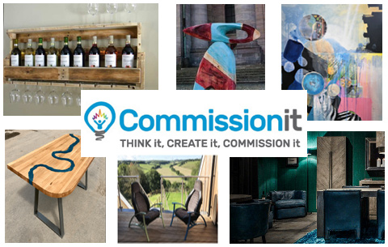
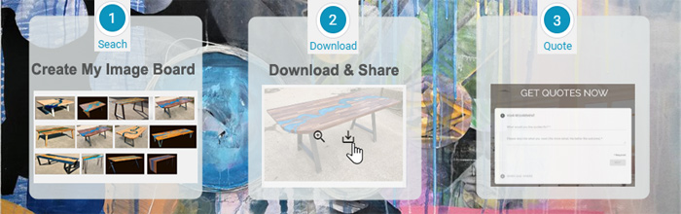
About Commission It
105 Heathwood Gardens, London,
SE7 8ET
0208 317 2014
07771 557500

Founder Amin Saleem previously founded and sold the government award-winning consumer champion platform in the car industry, AutoeBid. It took over £230m in orders and reached over 1 million unique UK visitors. Contact Amin Saleem on Linked In : https://www.linkedin.com/in/amin-saleem-338b94

Website : https://www.commissionit.com
Email : info@commissionit.com

Instagram : commissionitworks
Facebook: commissionworks
Pinterest: commissionit
Youtube: channel/UCfAyM1krpW6Yn8_-zlgglww
Twitter: commissionitltd

Date -11th March 2018

