- Run this query in the editor with F9.

with data as
(select 1 num, sysdate - 10 a_date from dual union all
select 2 num, sysdate - 9 a_date from dual union all
select 3 num, sysdate - 8 a_date from dual union all
select 4 num, sysdate - 7 a_date from dual union all
select 3 num, sysdate - 6 a_date from dual union all
select 7 num, sysdate - 5 a_date from dual union all
select 5 num, sysdate - 3 a_date from dual union all
select 6 num, sysdate - 2 a_date from dual union all
select 8 num, sysdate - 1 a_date from dual)
Select * from data
- Right-click on the grid and choose “Report”
- Just click “Finish” in the “Report Wizard” dialog. This is really more for tabular reports.
- Select and delete the “Master Data” band in the report, as well as PageHeader and PageFooter bands.
- Click on the LHS toolbar, 2nd to last button (Chart object) , then click on the report to drop it there.
- Click “Add Series” in the dialog
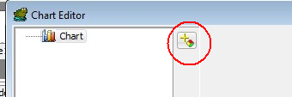
- Choose a bar chart in the next dialog
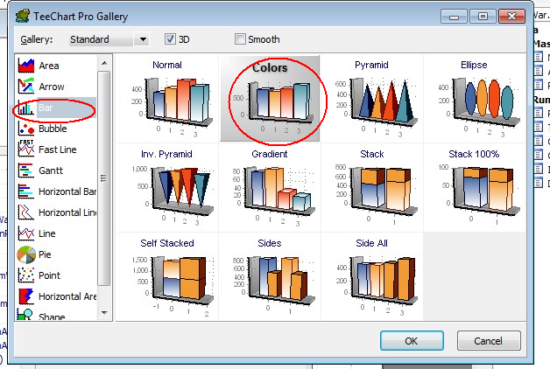
- Click OK and fill in the other dialog like this:
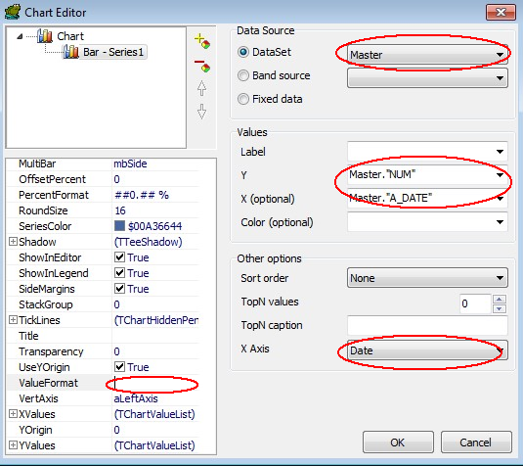
- Click OK and then resize the chart object in the report so it takes up most of the page.
- Hit F9 to run it.
- If you want, you can then go back and play with the series settings to change the look of the graph.
- If you save the report design to a FR3 file, and leave that file in place, then whenever you run that same query in Toad, and go to “Report” from the grid, Toad will remember which FR3 file to use, and will bring up the saved report design
This was a very quick, very basic lesson. Fast Reports is actually pretty powerful. To see some more advanced reports, go to Database -> Report -> Report Manager from Toad’s main menu.

