Problem: I created a trigger on a table using sqlplus. If I try an alter the trigger in toad (version 10.6) there is no issue but if I try an alter the same trigger in toad (version 12.1.0.22) the “Fire When” check boxes are unchecked. If re-check the appropriate “Fire When” checkboxes and save. The next time I alter the trigger they are still checked.
Alter Trigger screen in 10.6.
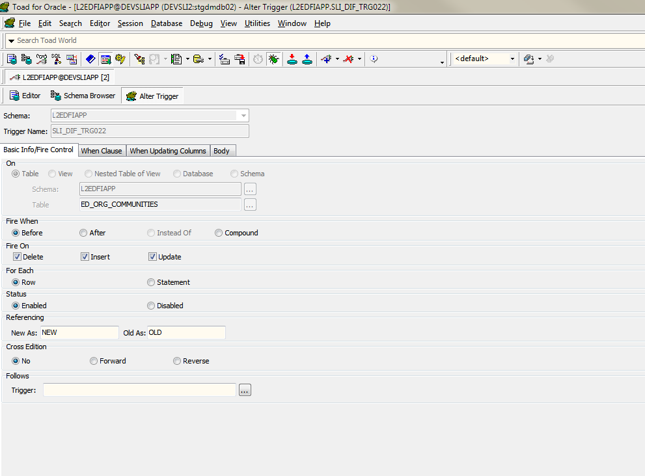

Alter trigger screen in 12.1.0.22. (First time altering the trigger in 12.1.0.22)
Fire When checkboxes are unchecked
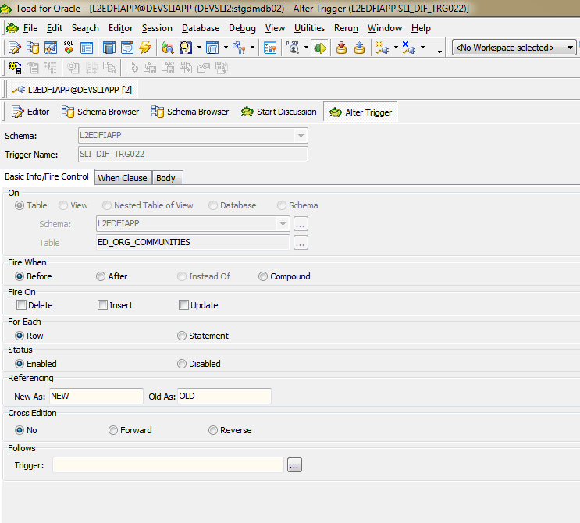

Alter trigger screen in 12.1.0.22. (Second time altering the trigger in 12.1.0.22)
“Fire When” checkboxes are checked this time.

