This is how it looks before you add a folder:

You add a new folder:
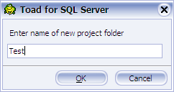

Once you click OK every sub folder is then opened and I’m not sure why it needs to do that, also it doesn’t default to the New Folder you just added, as you can see the folder at the to has the focus

