Public Notice

(A) The home inspector board. in giving public notice as to the adoption, amendment. or rescission of any rule required to be adopted under Chapter 119. of the Revised Code. shall publish a notice. at least once. in the register of Ohio and in such other publications as the board may determine from time to time. The notice shall appear at least thirty days prior to the date set for the hearing of the proposed action on any such rule. The notice shall meet the requirements of division (A) of section 119.03 of the Revised Code.

(8) The public notice shall specify the date. time and place of the hearing and shall include:

( 1) A statement of the intention to consider adopting. amending or rescinding a rule and the purpose or reason therefor;

(2) A synopsis of the proposed rule. amendment or rescission or a general statement as to the subject to which it relates.

(C) The home inspector board may give additional notice of such public hearing as it deems necessary: however. the giving of such additional notice shall not be mandatory and the failure to give notice by any means other than as specified in paragraph (A) of this rule shall not in any way invalidate any action which may be taken by the home inspector board.

Open Public Meeting

- Any person may ascertain the time and place of all regularly scheduled meetings and the time. place. and purpose of all special meetings of the home inspector board by:

  - Writing to the fol1owing address - "Home Inspector Board. Division of Real Estate and Professional Licensing, 77 South High Street. Columbus. Ohio 43215-6133." or

  - Calling the following telephone number during normal business hours - 614-466-4100. or

  - Accessing the division of real estate and professional licensing website.

- Any person may receive notice of all meetings of the home inspector board. The superintendent shall cause a mailing list to be maintained of all persons who have requested notification. Any person wishing to receive notification shall notify the superintendent that they wish to be included on the mailing list for such notices. Requests may:

(I} Be given in writing to the address given in paragraph (A)(]) of this rule or by electronic mail sent to webreal@.com.ohio.gov or such other address as may from time to time be published on the division's web site.

- State that the requestor wishes to be notified of all public meetings of the board or those at which specific topics stated by the requestor are to be discussed.

- Indicate if the requester wishes to be notified by electronic mail. fax. or printed notice.

- Provide the requestor's electronic mail address. mailing address or fax number.

- State if the requestor is a media representative who wishes to be notified of special meetings pursuant to division (F) of section 121.22 of the Revised Code. If a media representative requests notice of special meetings the media representative shall also provide no more than two telephone numbers at which they may be reached.

- The superintendent shall cause a notice to be distributed to all persons on the mailing list at least five calendar days before each regularly scheduled meeting of the board. The superintendent shall make all reasonable effort to provide notice of all special meetings in compliance with division (F) of section 121.22 of the Revised Code.

- Fees shall be assessed in conformity with the Ohio department of commerce public records request policy and division (B) of section 149.43 of the Revised Code.

Fees

The applicable nonrefundable fees shall be assessed by the home inspector board as follows:
- A two hundred thirty-five dollar fee for initial licensure as a home inspector. This fee is in addition to any special assessment ordered by the board pursuant to section 4764.21 of the Revised Code.

- A two hundred thirty-five dollar fee for the renewal of a home inspector license. This fee is in addition to any special assessment ordered by the board pursuant to section 4764.21 of the Revised Code.

- A one hundred twenty-five dollar fee for an applicant of a renewal of a home inspector license who has filed the renewal within three months after the expiration of the license. The late filing fee must be submitted with the renewal application for licensure. This late fee is in addition to any fees found in paragraph B of this rule.

- A twenty-five dollar fee must be submitted to the division for any of the following: a certificate of licensure: a replacement license that must be issued due to the original license being lost or spoliated: the licensee requests a change to the licensee's information on file with the division.
5

- A six-hundred dollar fee for the approval of any type of course offering. whether online or in a classroom setting, which is presented as satisfying the home inspector education requirements found in section 4764.0S(C) of the Revised Code. A fifty-dollar fee shall be assessed for any amendments or changes to the class curriculum or materials.

- A one-hundred dollar fee for the approval of an initial course offering of classroom education presented as satisfying home inspector continuing education. A fifty-dollar fee shall be assessed for any amendments or changes to the class curriculum or materials. A one-hundred dollar fee for approval of classroom education presented as satisfying home inspector continuing education that was taken outside the State of Ohio and was not previously approved by the superintendent to its completion.

- A two-hundred dollar fee for the approval of any on-line offering presented as satisfying home inspector continuing education. A fifty-dollar fee shall be assessed for any amendments or changes to the class curriculum or materials. A one-hundred dollar fee for approval of on-line education presented as satisfying home inspector continuing education that was taken outside the State of Ohio and was not previously approved by the superintendent to its completion.

- If a check or other draft instrument used to pay any fee required is returned to the superintendent unpaid by the financial institution upon which it is drawn for any reason. the superintendent shall notify the person that the check or other draft instrument was returned for insufficient funds. A one-hundred dollar insufficient fund fee shall be

Fees

assessed. and any application approval shall be withdrawn pending timely payment of all fees.

- The superintendent of real estate may require that fees be paid by credit card. debit card. personal check. cashier's check. certified check. money order or electronic funds transfer.

Out of State Applicants

  - An applicant for an initial Ohio home inspector license may obtain a license pursuant to Ohio Revised Code Section 4764.10 provided the following. including but not limited to. are satisfied:

    - The applicant completes an application prescribed by the superintendent:

- The applicant submits to criminal background check as found in Ohio Revised Code Section 4764.07(8):

- The applicant satisfies all the requirements of Ohio Revised Code Section 4764.10: and

- Payment of appropriate fees required by rule {insert new rule number) of the Administrative Code.

(8) Any applicant for an Ohio home inspector license who is doing business in Ohio as. including but not limited to. a sole proprietor, a corporation, a partnership, limited liability corporation, limited liability partnership or an association shall file or register with the Ohio Secretary of State.

- The signature on any application may be written by hand or be an electronic signature. as defined by division (H) of section 1306.0 I of the Revised Code.

- Upon notice from the division of real estate that an application for initial licensure is incomplete or incorrect as filed. the applicant shall within thirty days of the date of the last such notice submit to the division a corrected application or the additional information requested. Failure to timely submit such corrected application or additional information shall constitute just cause for the superintendent to void the application and impose a forfeiture of any application fee pursuant to section 4764.05 of the Revised Code.

Applications

- An applicant for an initial or a renewal of an Ohio home inspector license may obtain a license provided the following, including but not limited to, are satisfied:

  - The applicant completes an application form prescribed by the superintendent satisfying the requirements to be an Ohio licensed home inspector; and

  - Payment of appropriate fees required by rule (insert new rule number) of the Administrative Code.

- Any applicant for an Ohio home inspector license who is doing business in Ohio as, including but not limited to. a sole proprietor, a corporation. a partnership. limited liability corporation, limited liability partnership or an association shall file or register with the Ohio Secretary of State.

- The signature on any application may be written by hand or be an electronic signature. as defined by division (H} of section 1306.0 I of the Revised Code.

- Upon notice from the division of real estate that an application for initial licensure is incomplete or incorrect as filed, the applicant shall within thirty days of the date of the last such notice submit to the division a corrected application or the additional information requested. Failure to timely submit such corrected application or additional information shall constitute just cause for the superintendent to void the application and impose a forfeiture of any application fee pursuant to section 4764.05 of the Revised Code.

- A licensed home inspector who fails to renew a license prior to its expiration may, during the three months following the date of expiration. renew the license by submitting the following to the division

  - The applicant completes an application form prescribed by the superintendent satisfying the requirements to renew an Ohio home inspector license: and

  - Payment of a renewal fee and payment of a late renewal fee required by rule (insert new rule number) of the Administrative Code.

- A licensed home inspector who applies for late renewal shall not engage, following the expiration date of the license, in any activities permitted under the license being renewed until the superintendent notifies the licensed home inspector that the licensed home inspector's license has been renewed. If a licensee fails to satisfy any of the requirements to renew the license within three months following the date of the license's expiration, then a new home inspector license must be obtained pursuant to section 4764.07 of the Revised Code.

Education

  - An applicant for an initial home inspector license shall successfully complete at least eighty hours of classroom or online pre-licensing instruction in the following topics:

    - ) Foundations:
    - Framing:
    - Building Enclosure:
    - Roof Systems:
    - Plumbing Systems;
(6) Class room only
    - Electrical Systems:
    - HVAC Systems:
    - Appliances:
    - Ohio Standards of Practice:
    - Ohio Home Inspector Law:
    - Standard Report Form/Report Writing.

- The education required in paragraph (A) of this rule must be completed at an accredited public or private institution of higher education or a professional organization approved by the board to offer the education.
- Applicants must submit with the initial home inspector license application a certificate, transcript. letter or other similar documentation properly issued from the education provider at which the course or courses of education were completed. The superintendent of real estate may request supporting documentation to determine the acceptability of a particular course or courses.
- For applicants only applying to satisfy Ohio Revised Code Section 4764.07(D)(6)(a). a peer review session from the applicant's curriculum of experience is allowed by Ohio Revised Code Section 4764.0S{D} to satisfy the education requirements found in this rule. At maximum one peer review session may be submitted as part of the education requirements for a home inspector license. One peer review session shall count towards ten hours out of the eighty hours of education required for a license. The peer review session must comply with the Ohio Administrative Code.
- Upon notice from the division of real estate that an application is incomplete or incorrect as filed. the applicant shall. within thirty days of the date of the last such notice. submit to the division the additional requested information or the corrected application. Failure to timely submit the additional requested information or the corrected application shalt constitute just cause for the superintendent to void the application and impose a forfeiture of any application fee.

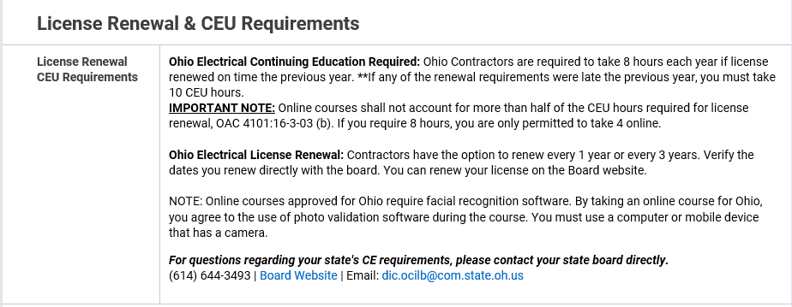

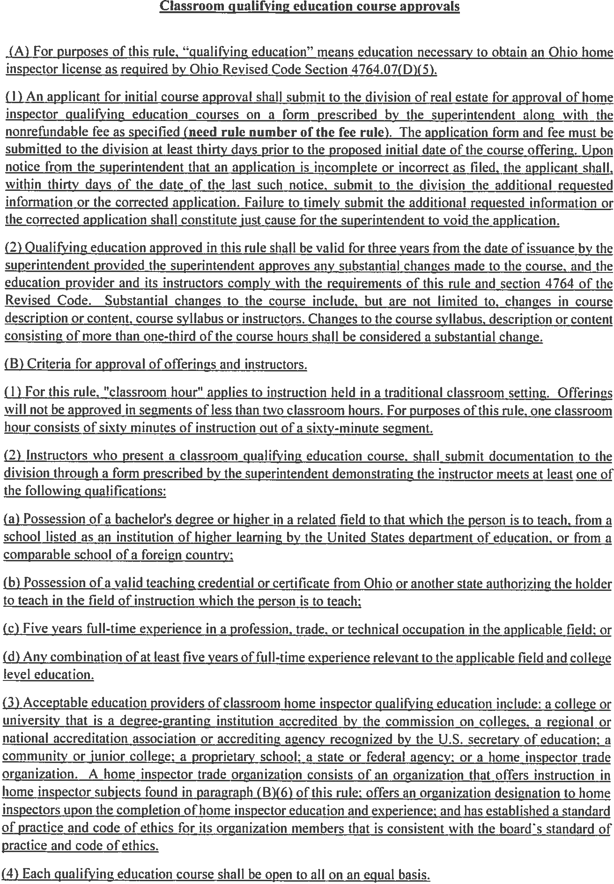
(e) Electrical courses to be taught by an Electrical Safety Inspectors.


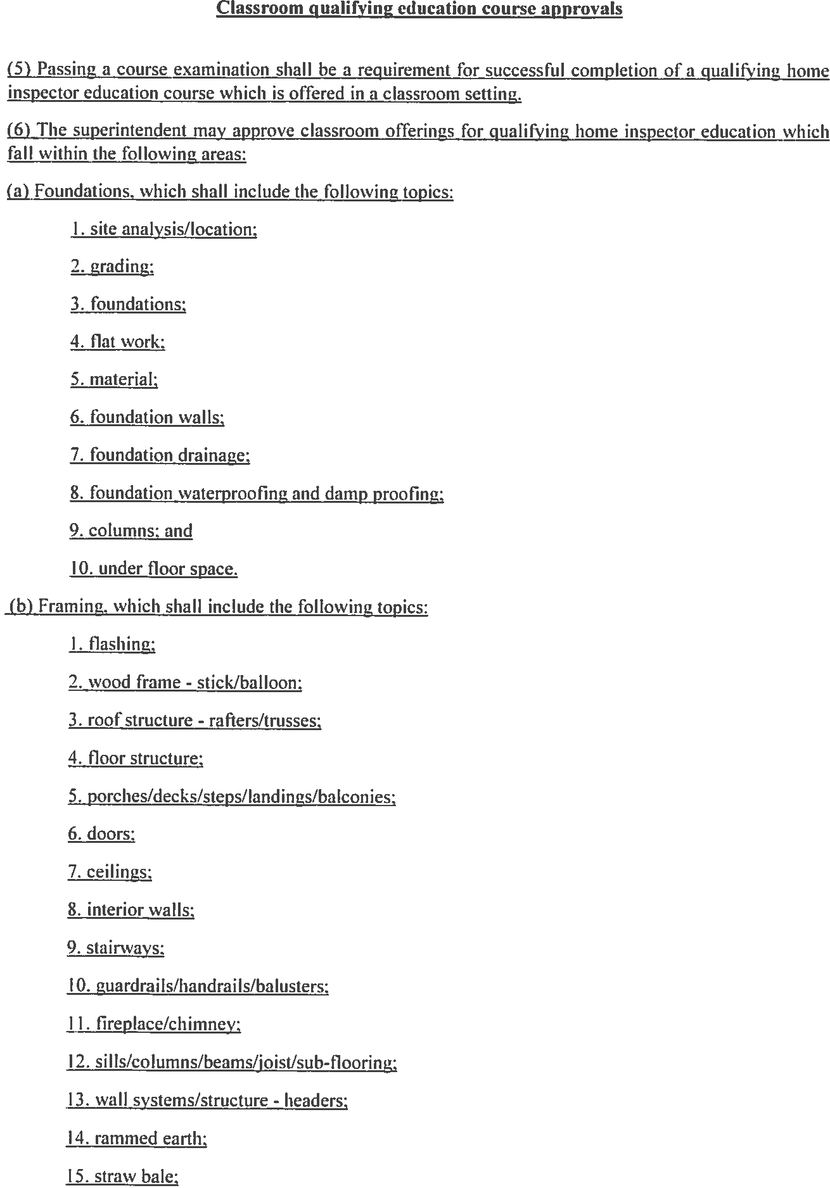
(5)


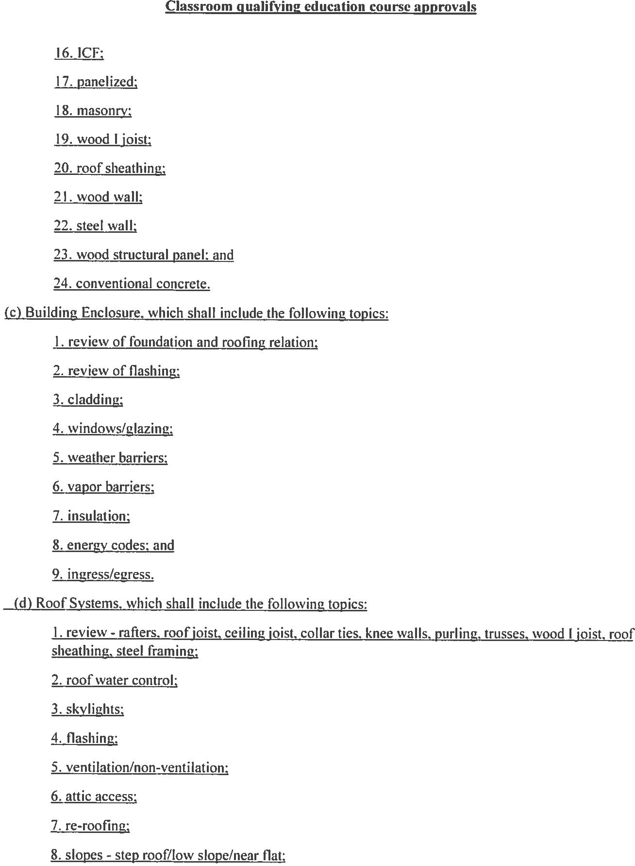


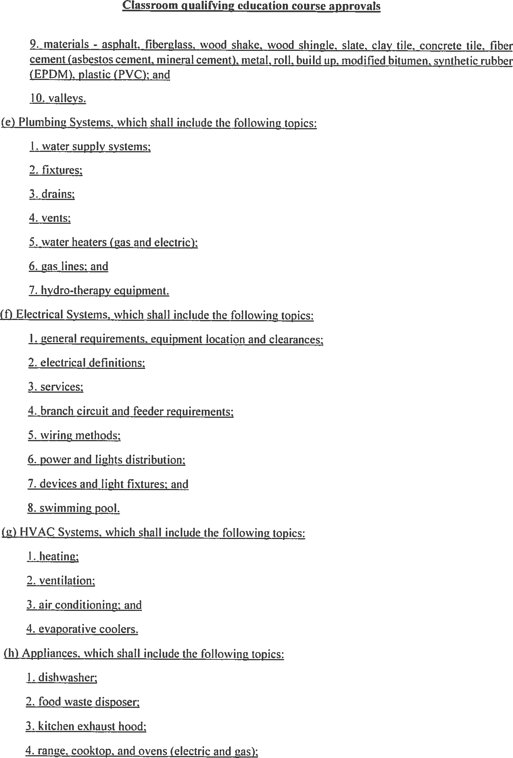
Verbiage to make it clear that all electrical inspection classes to be taught by an ESI


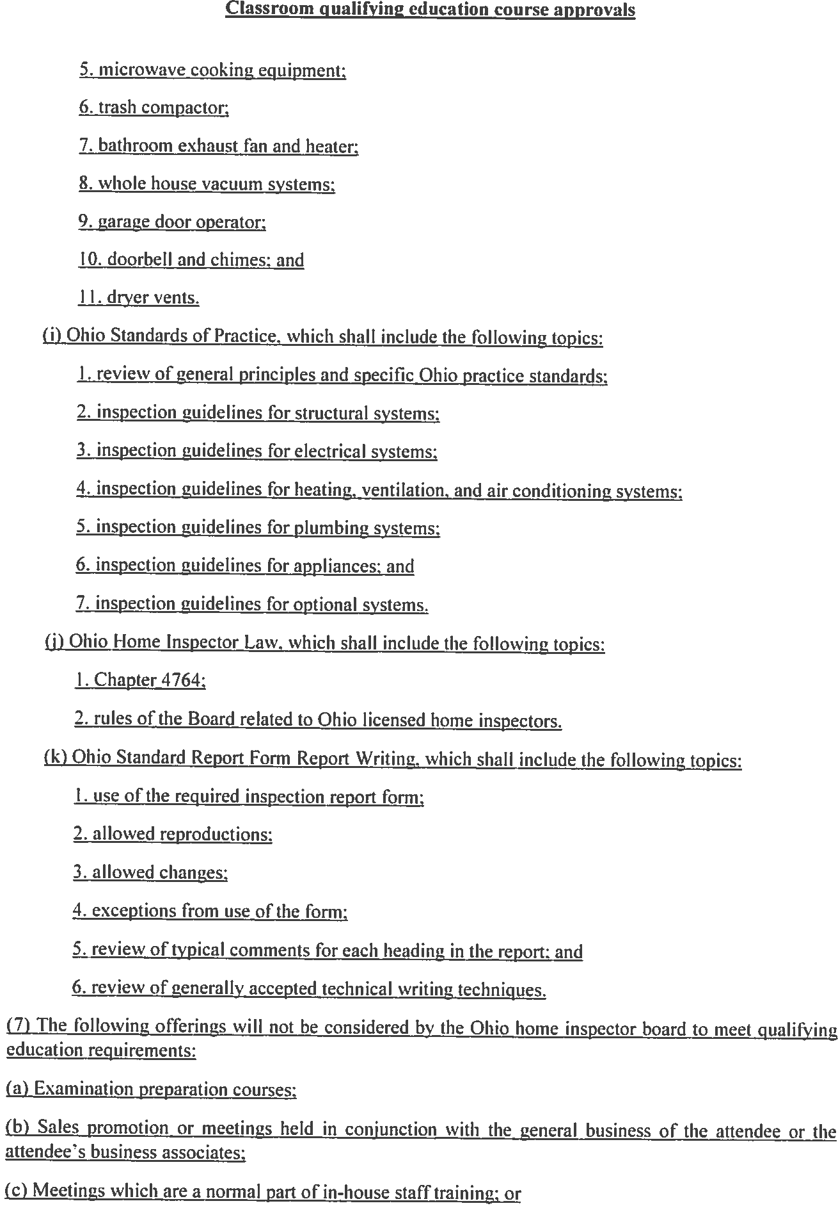
(6)


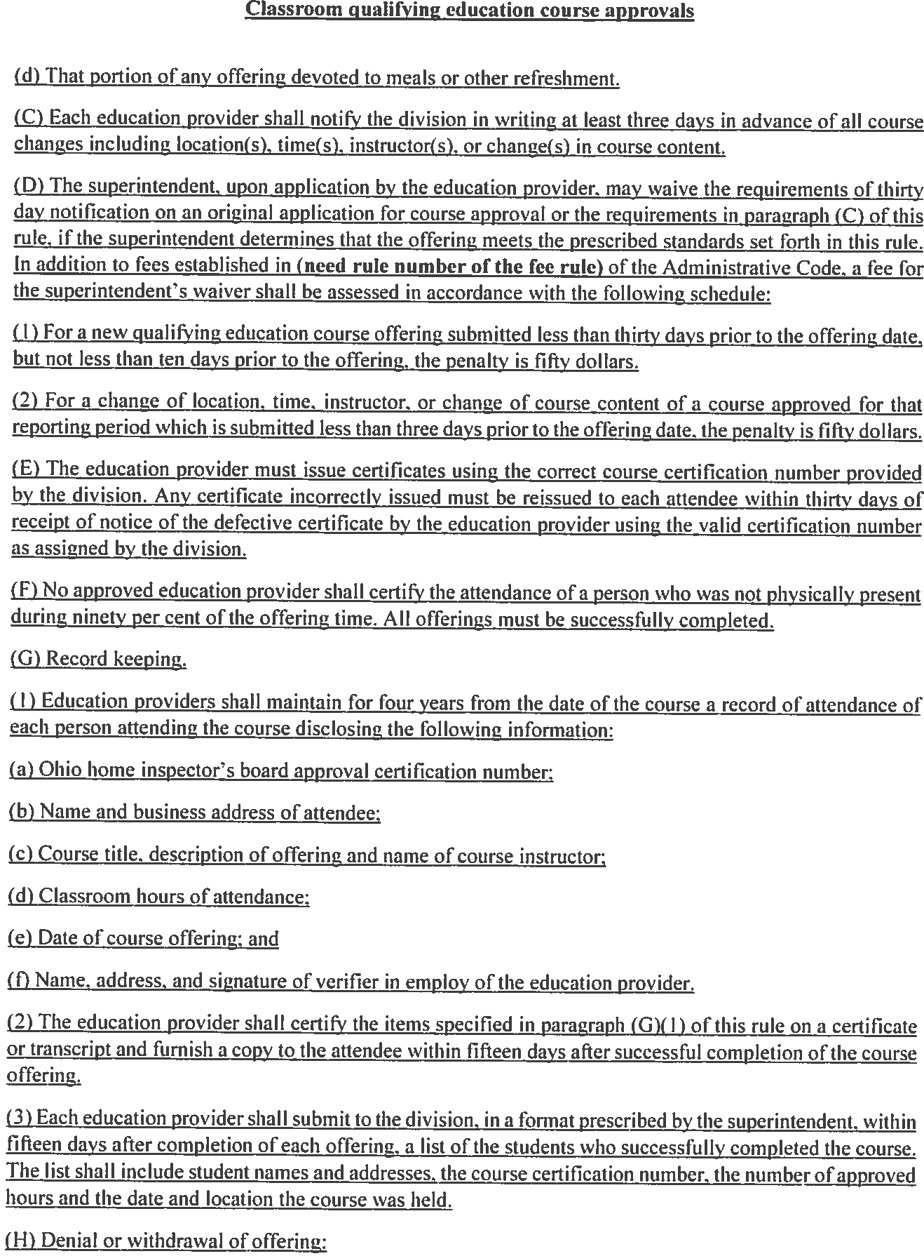


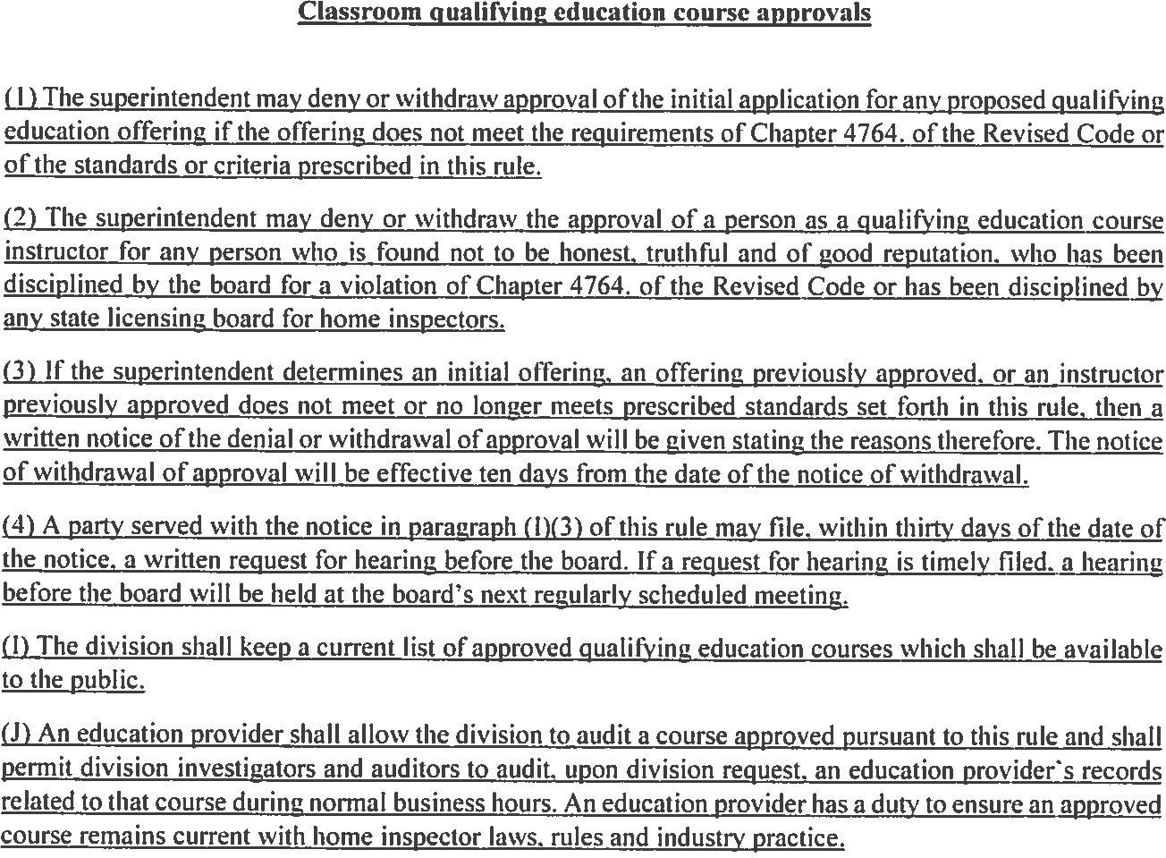


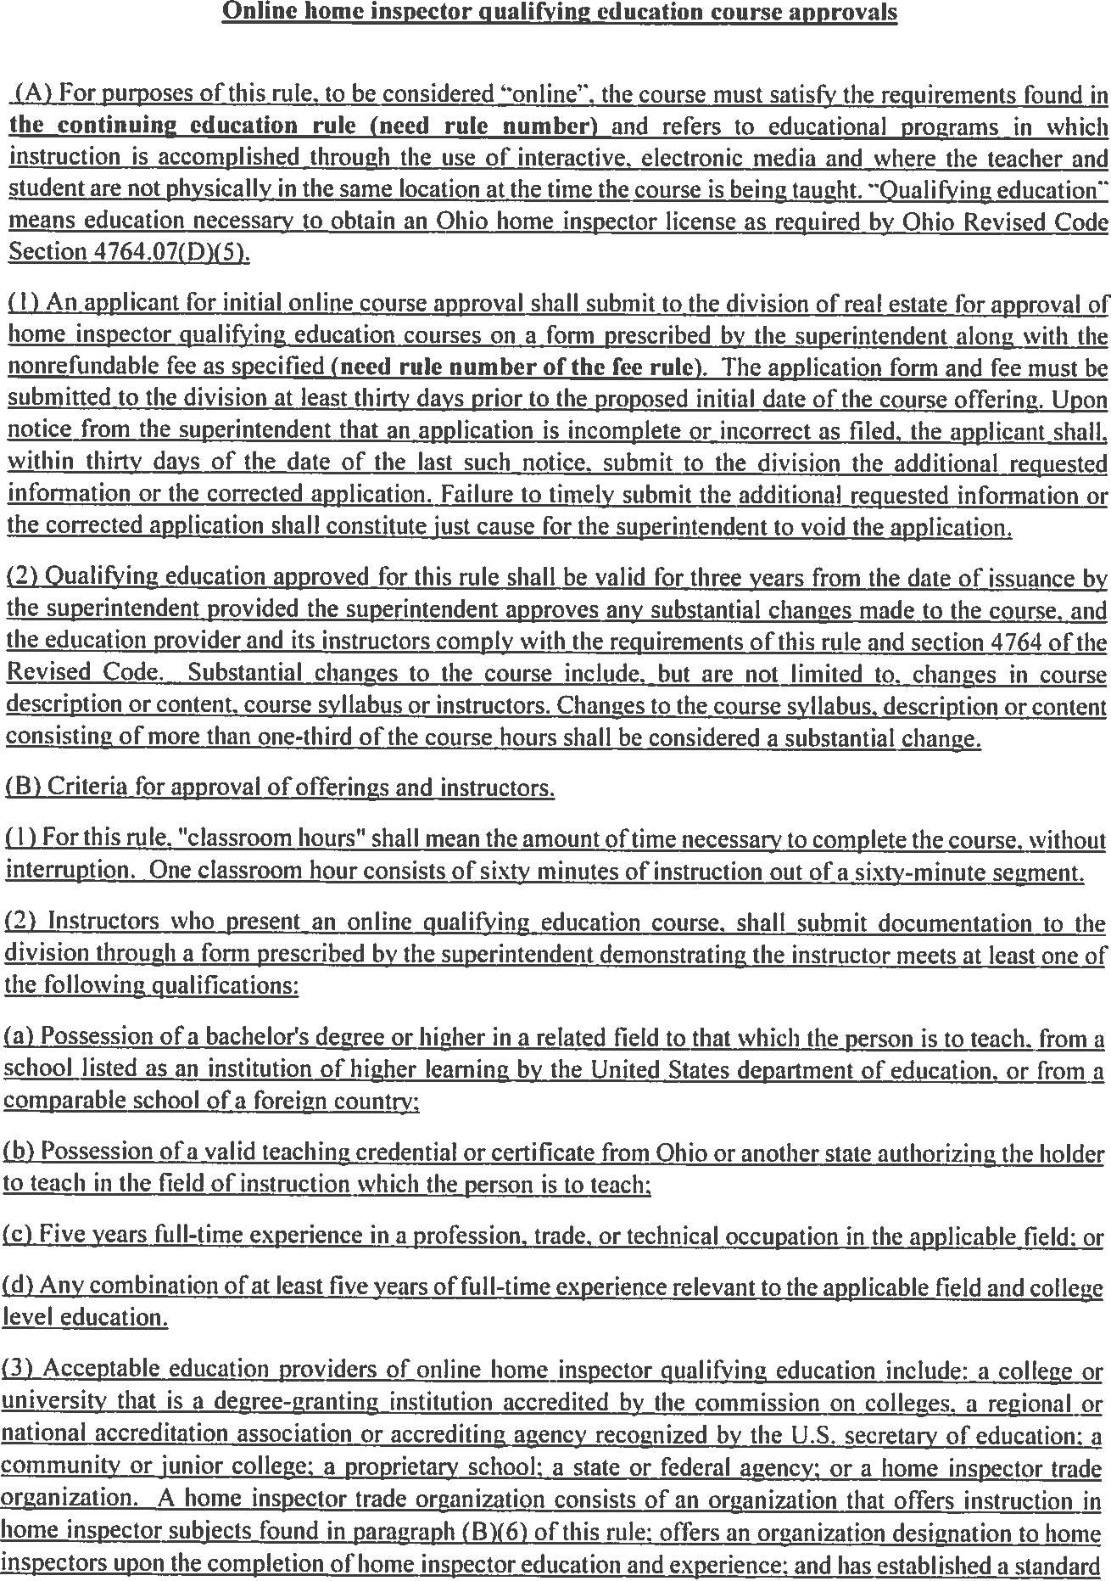


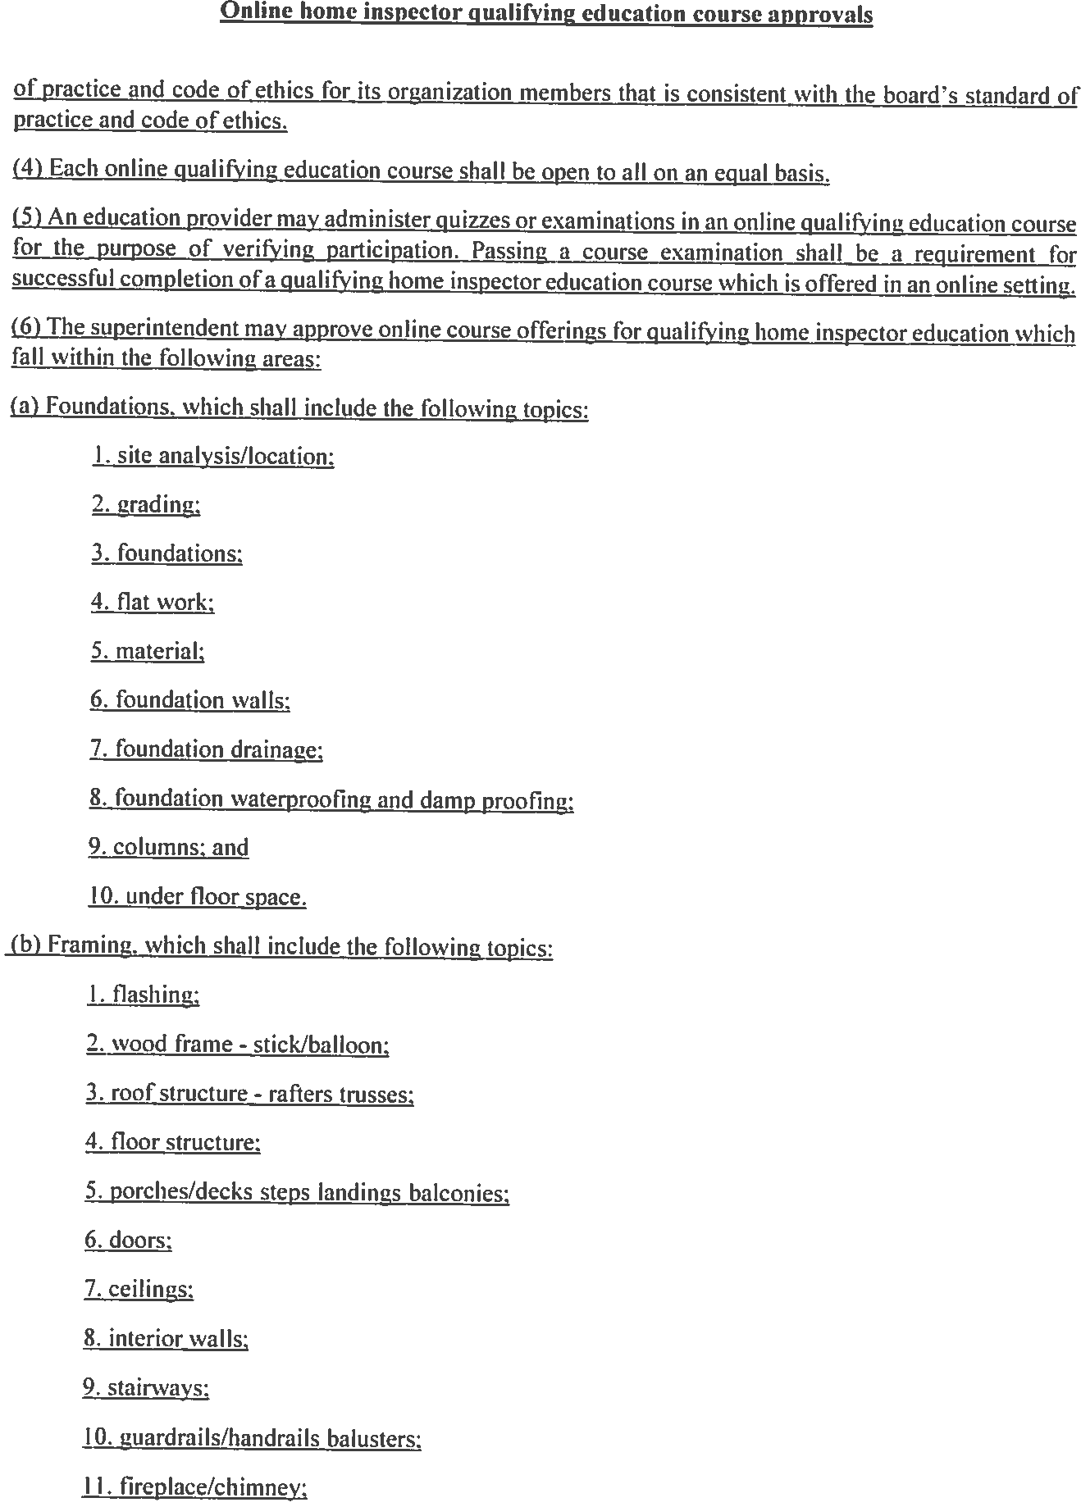


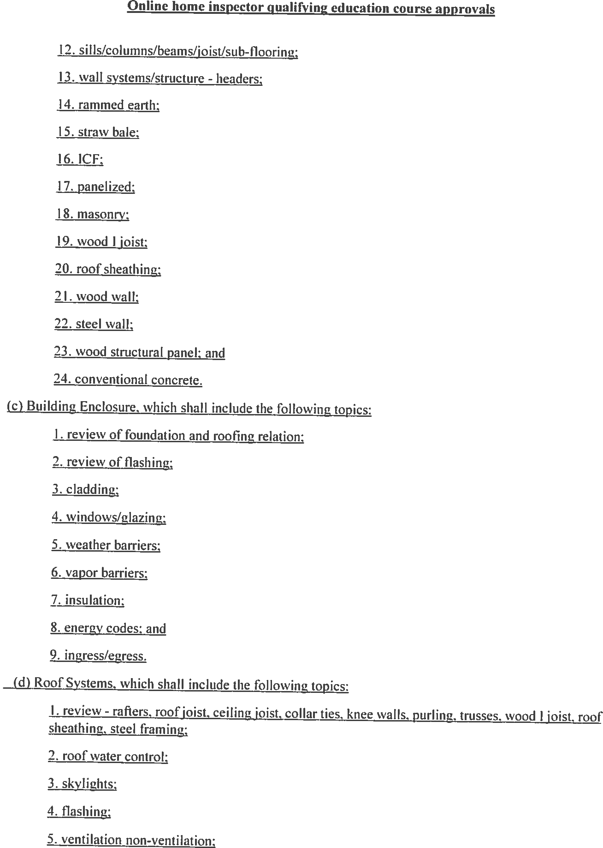


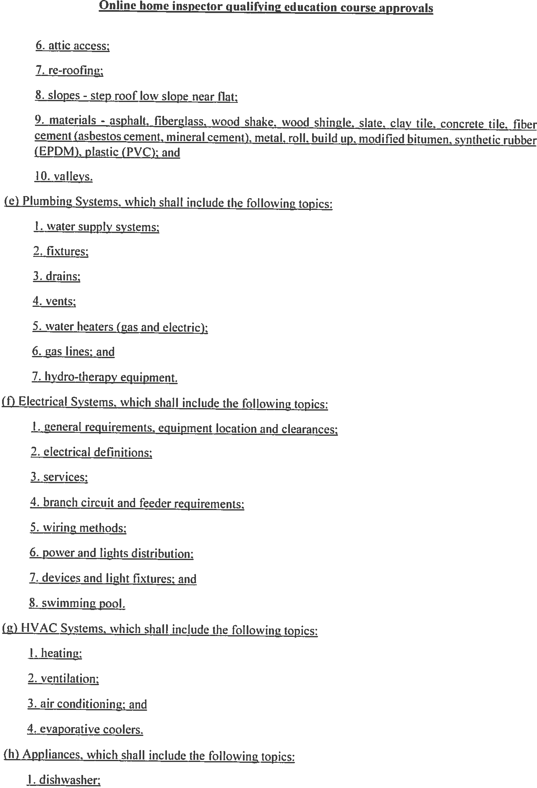
Classroom
Only
In state
Only
(g)
(f)


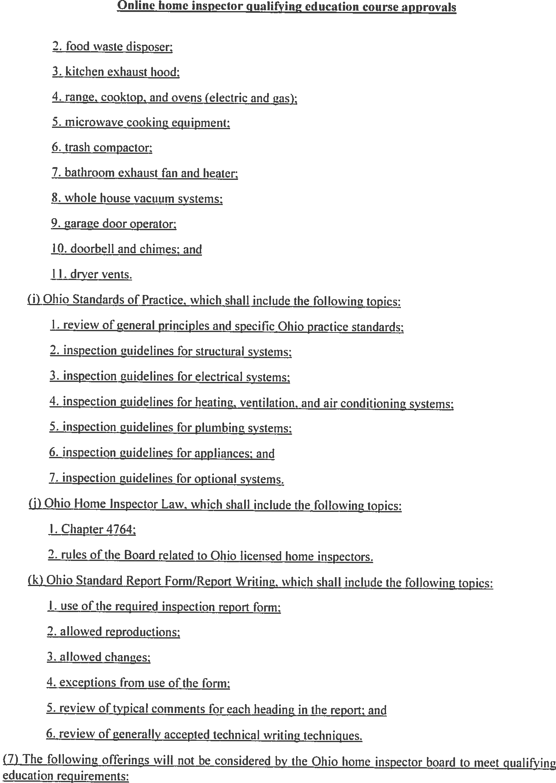
(i)
(h)
(j)


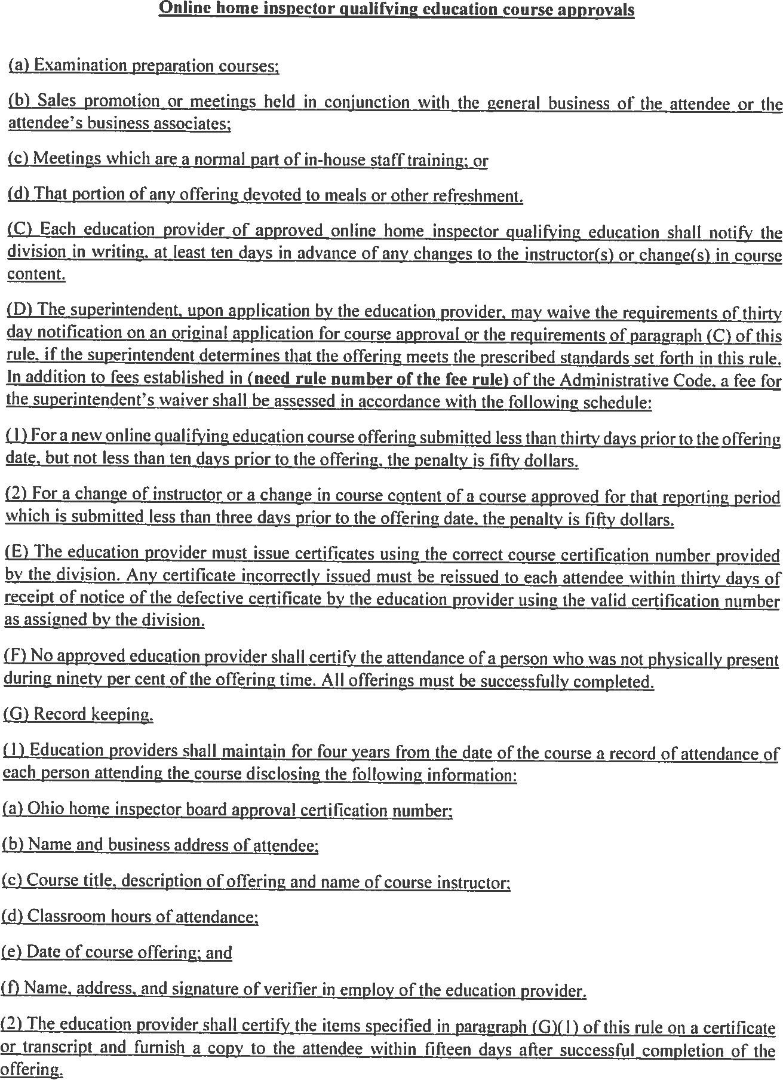


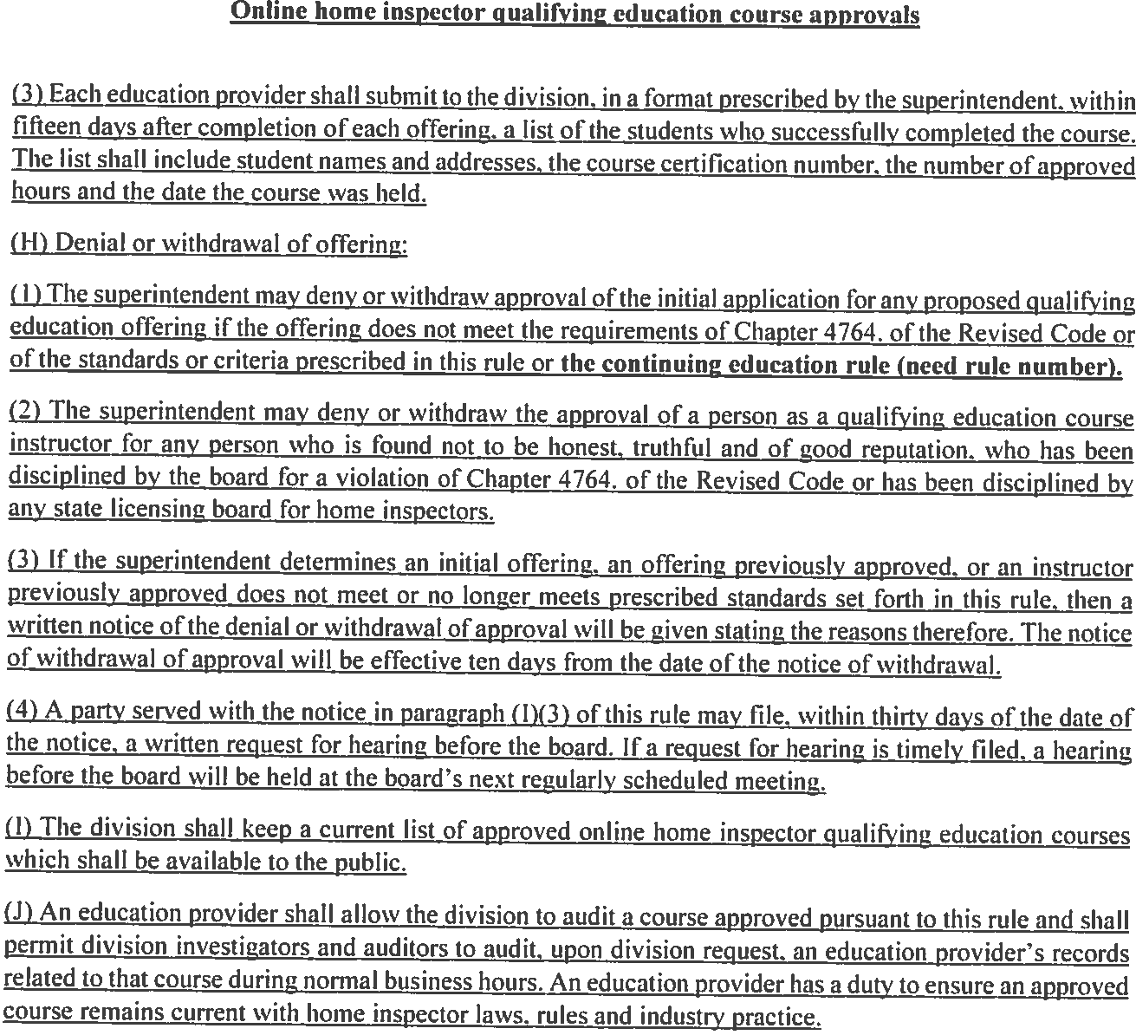


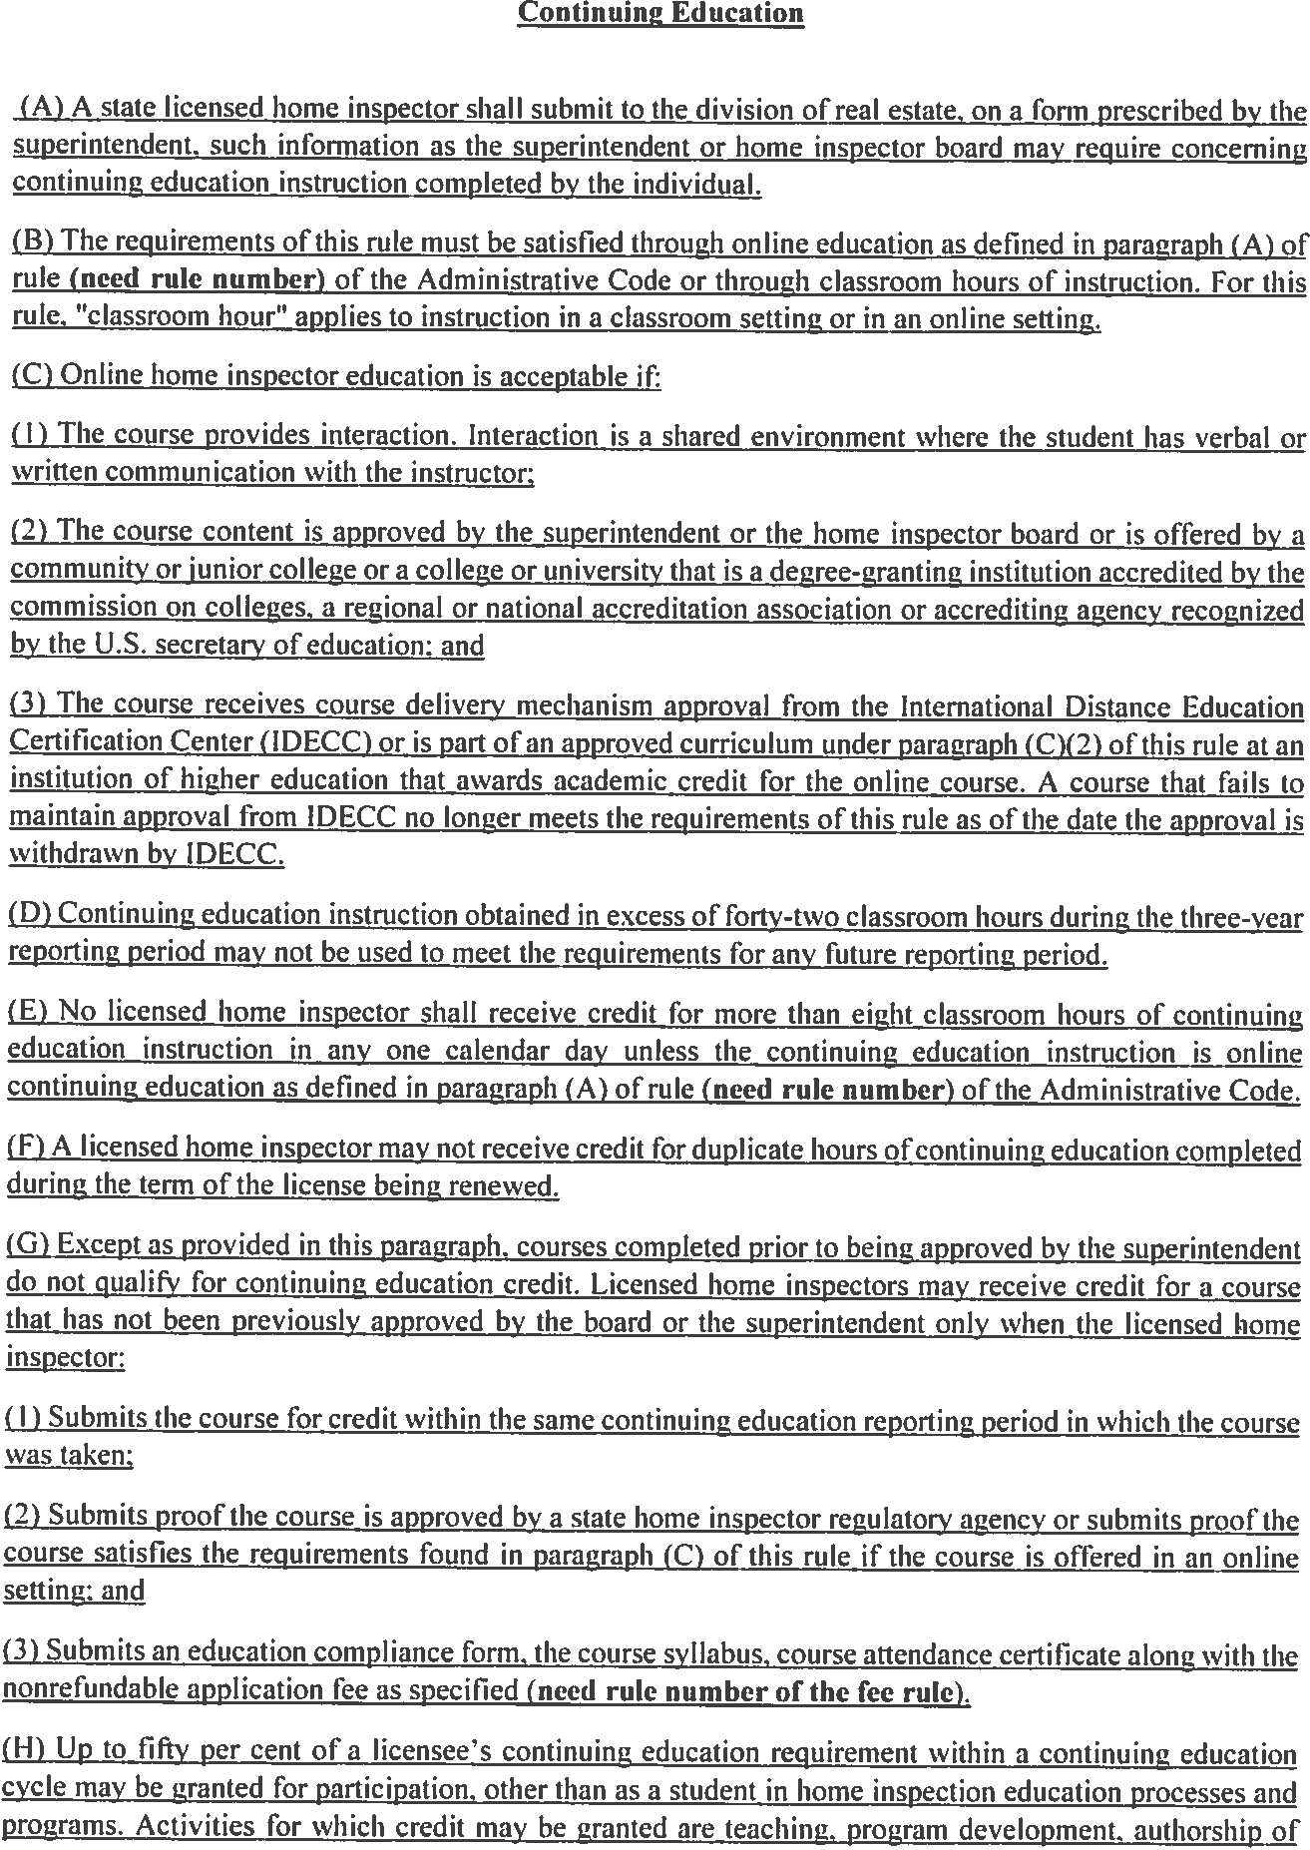

Delete G & H in their entirety


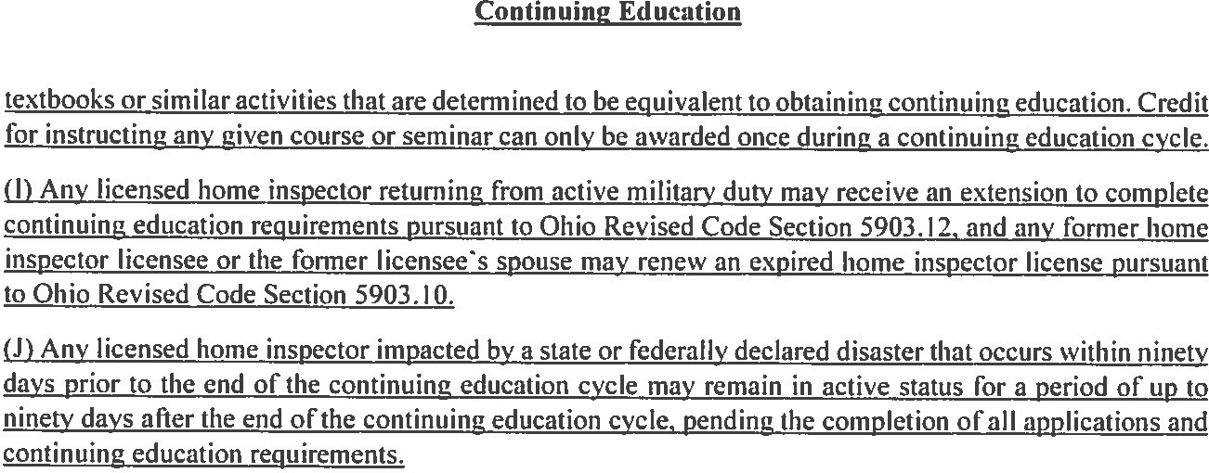
(G)
(H)

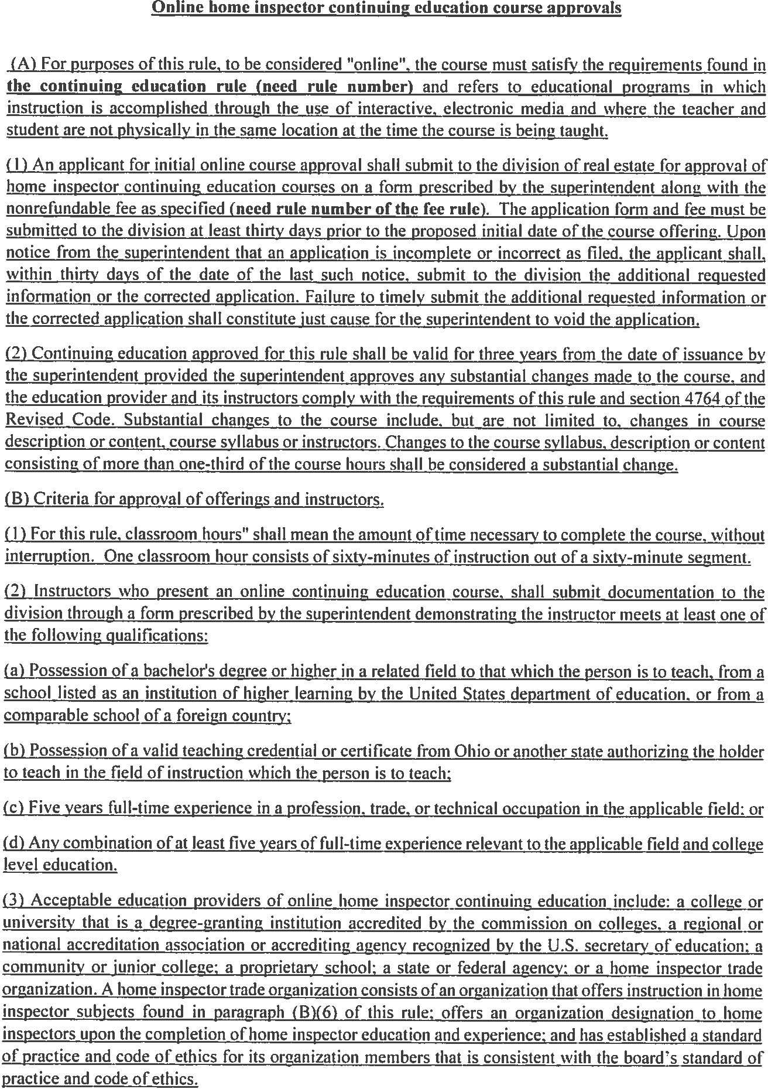
insert
(e) No online course may be given to meet any of the electrical inspections requirements in Chapter 4764.


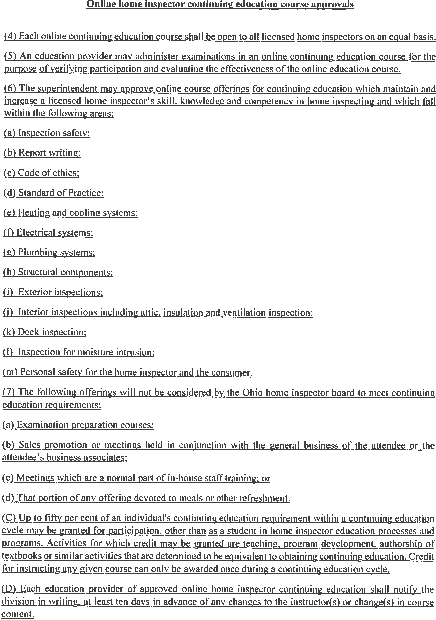
In classroom only, taught by an ESI


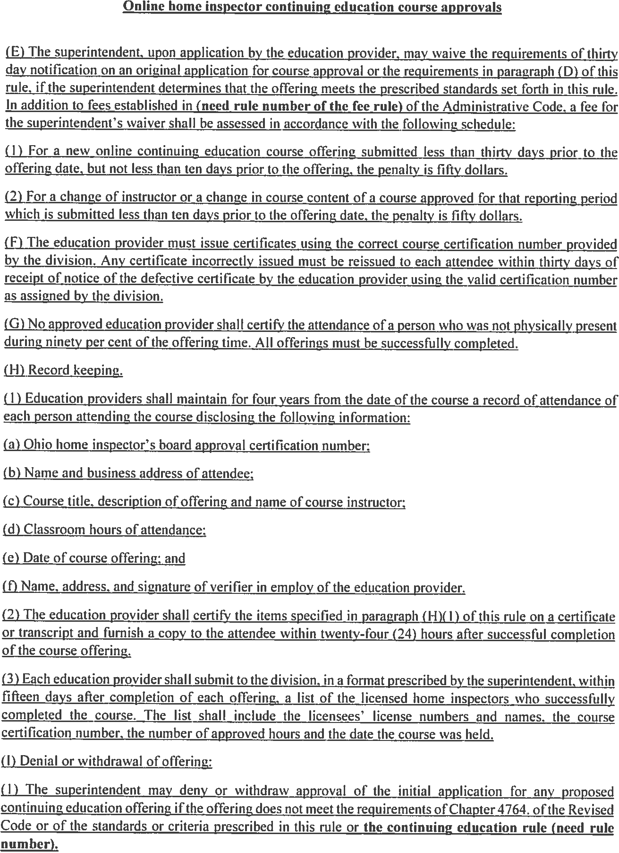
five hundred dollars


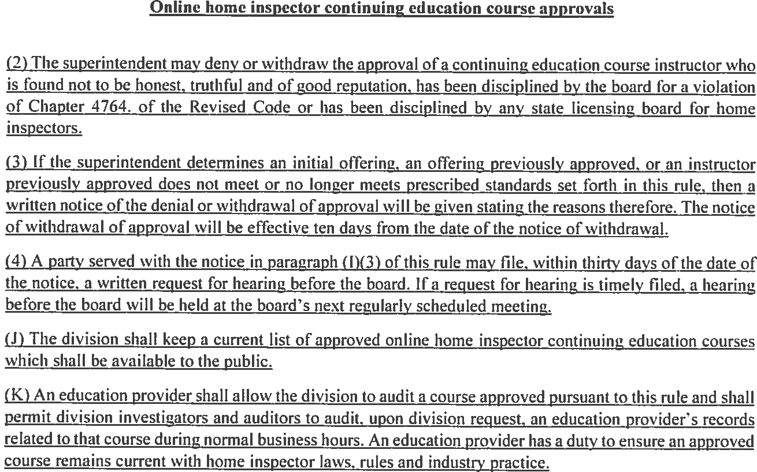


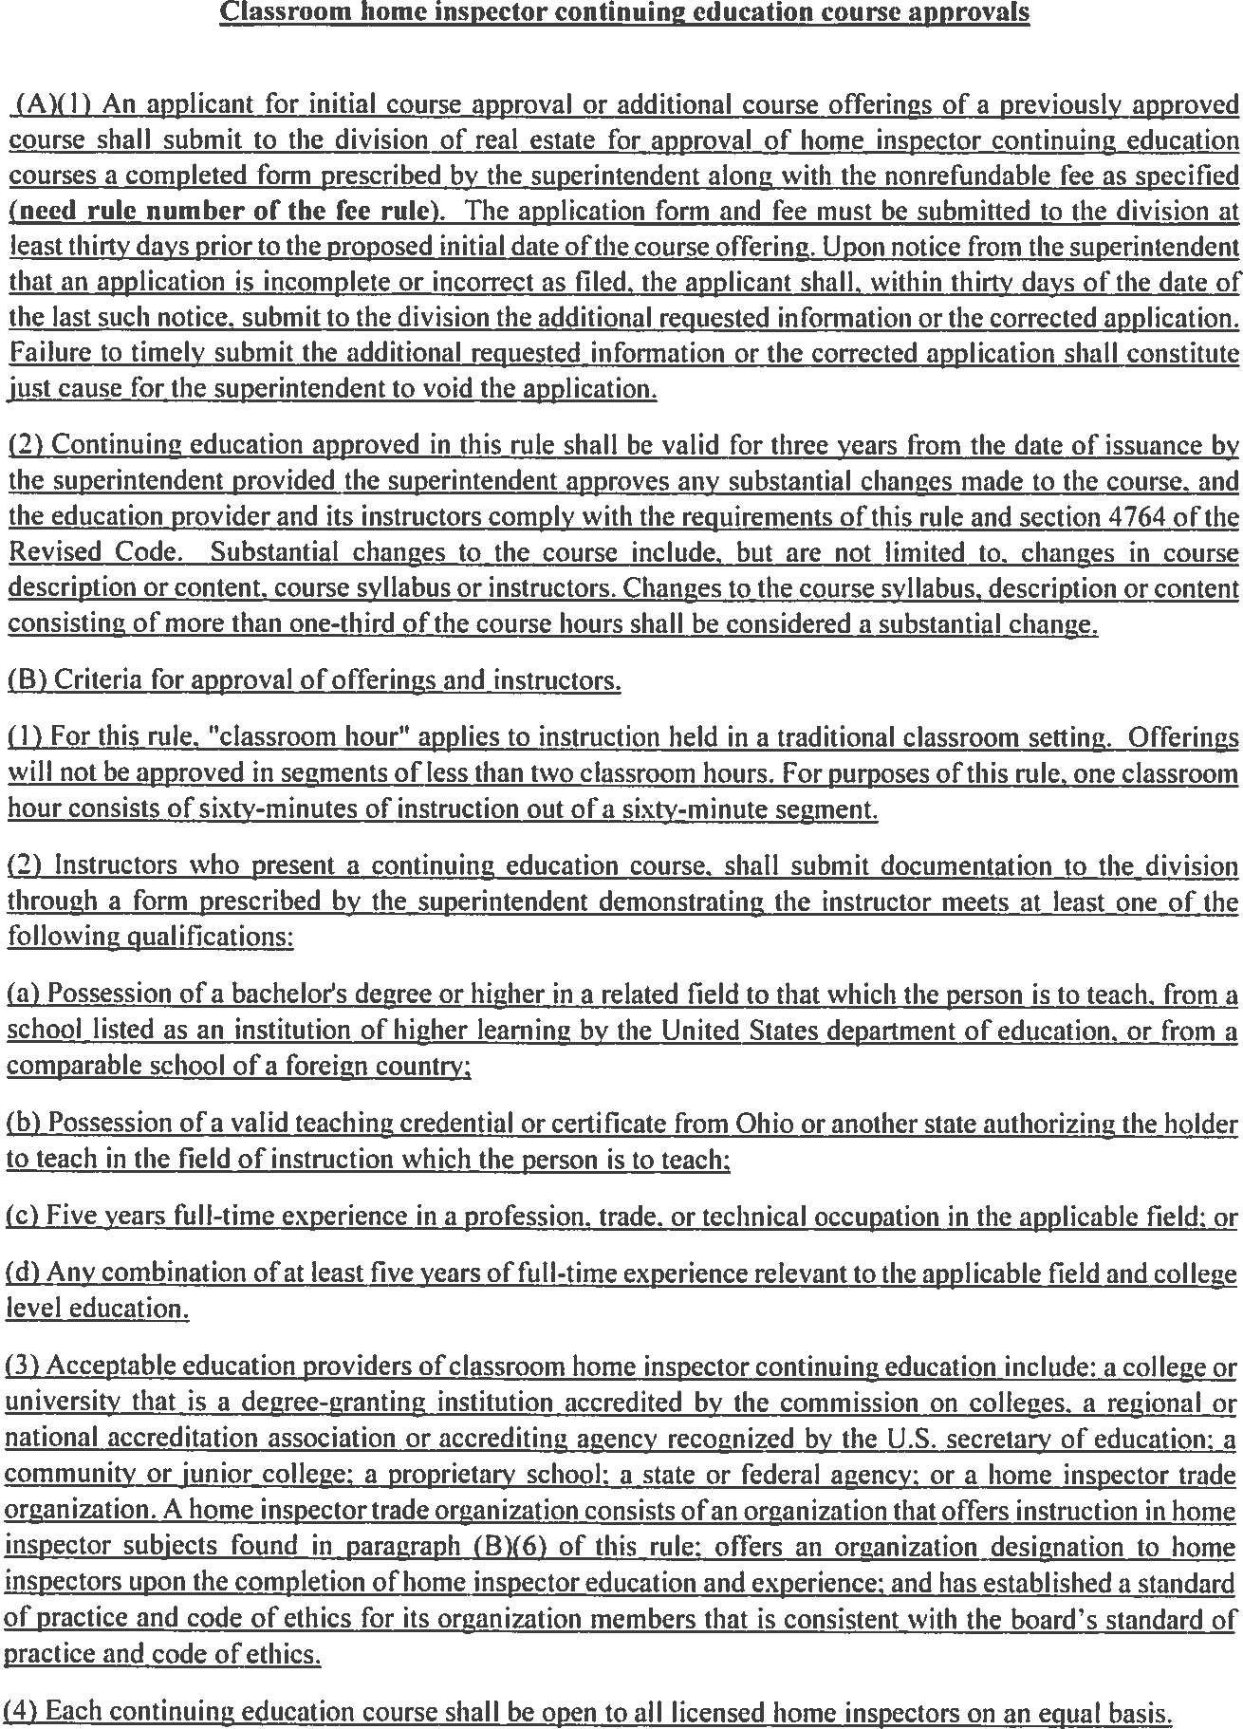
(e) Holder of a Certificate of Competency as an Electrical Safety Inspector. R.C. 3783.


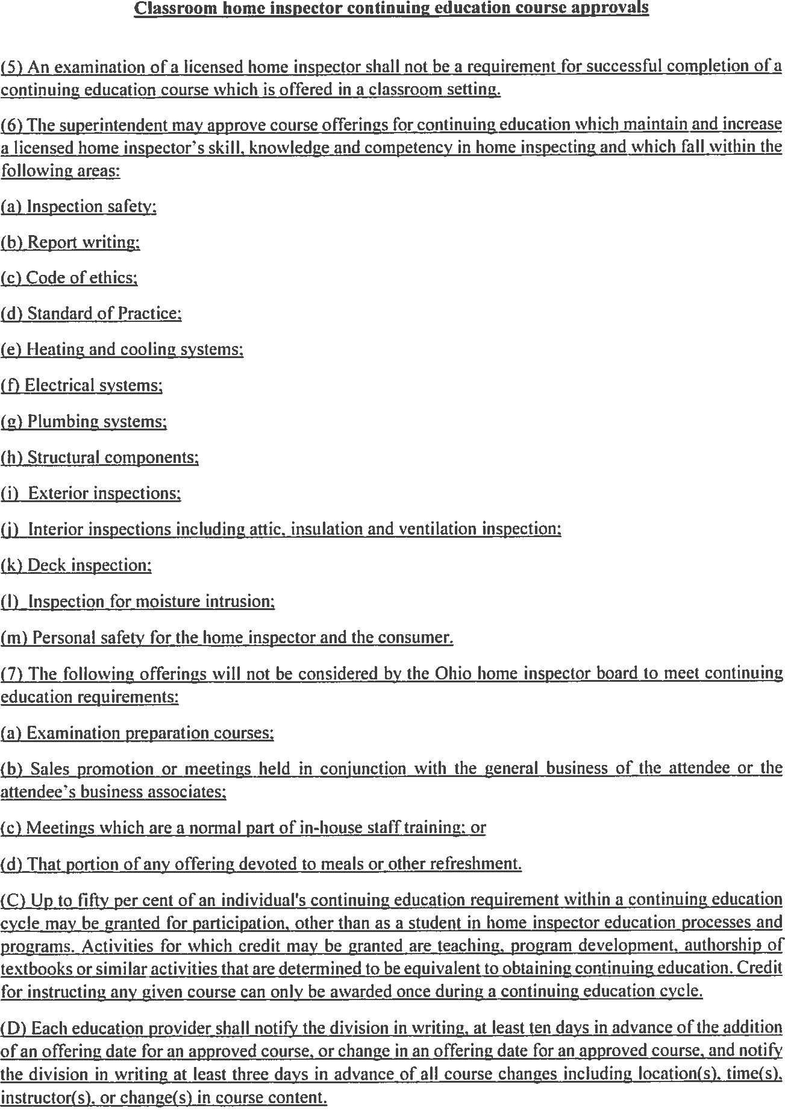
Must have prior BBS approval


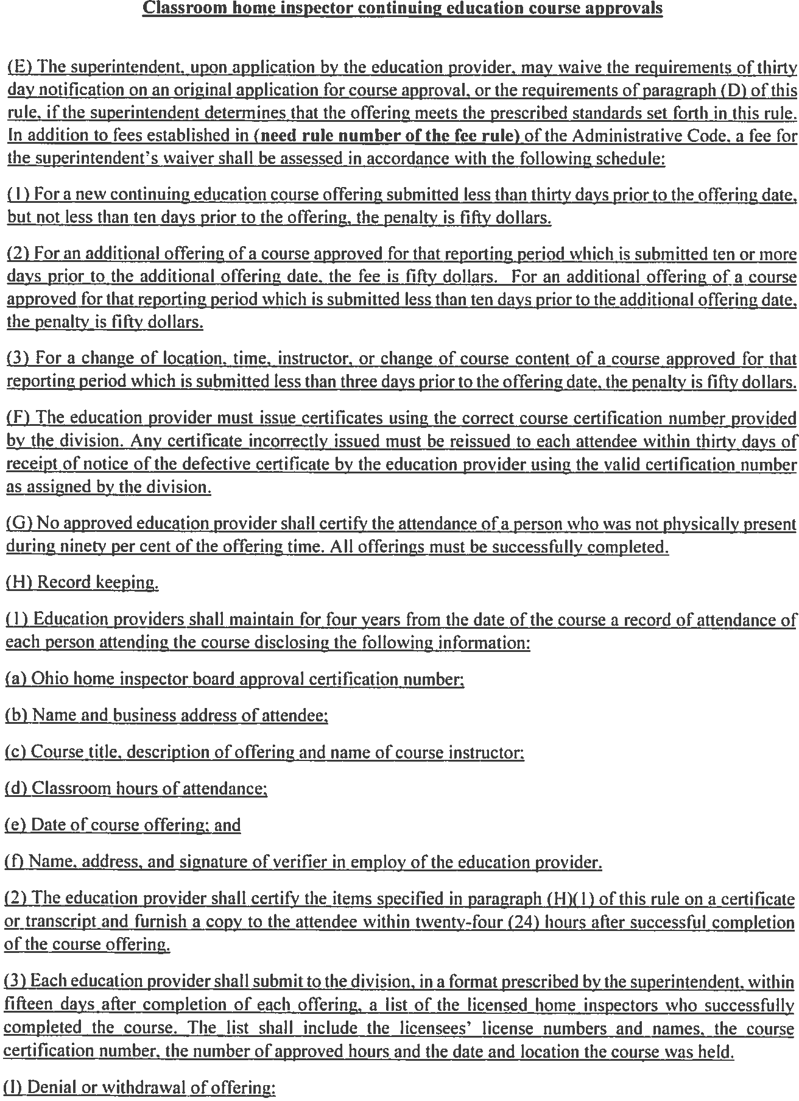
five hundred dollars


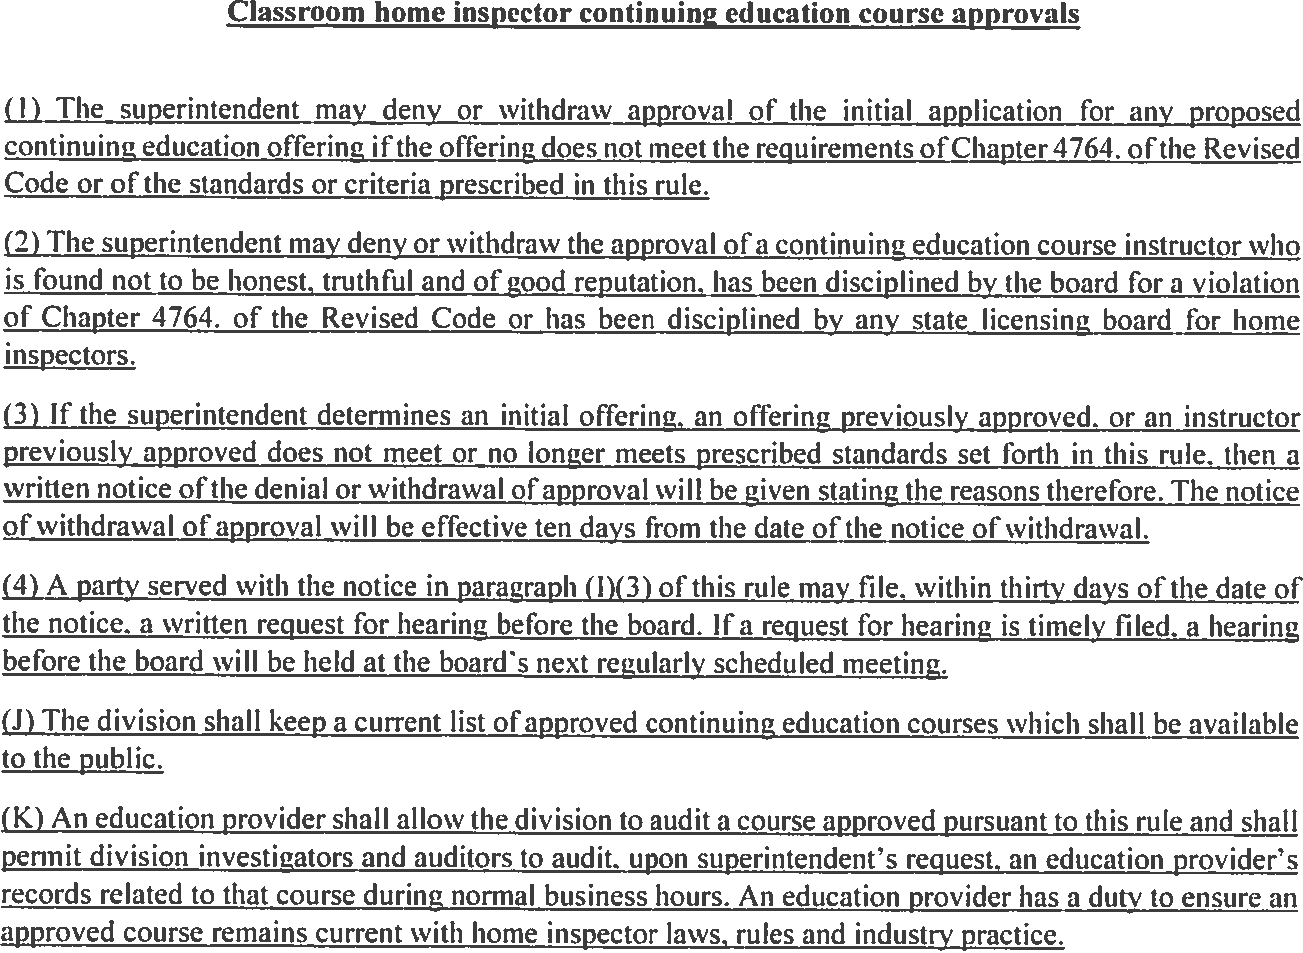


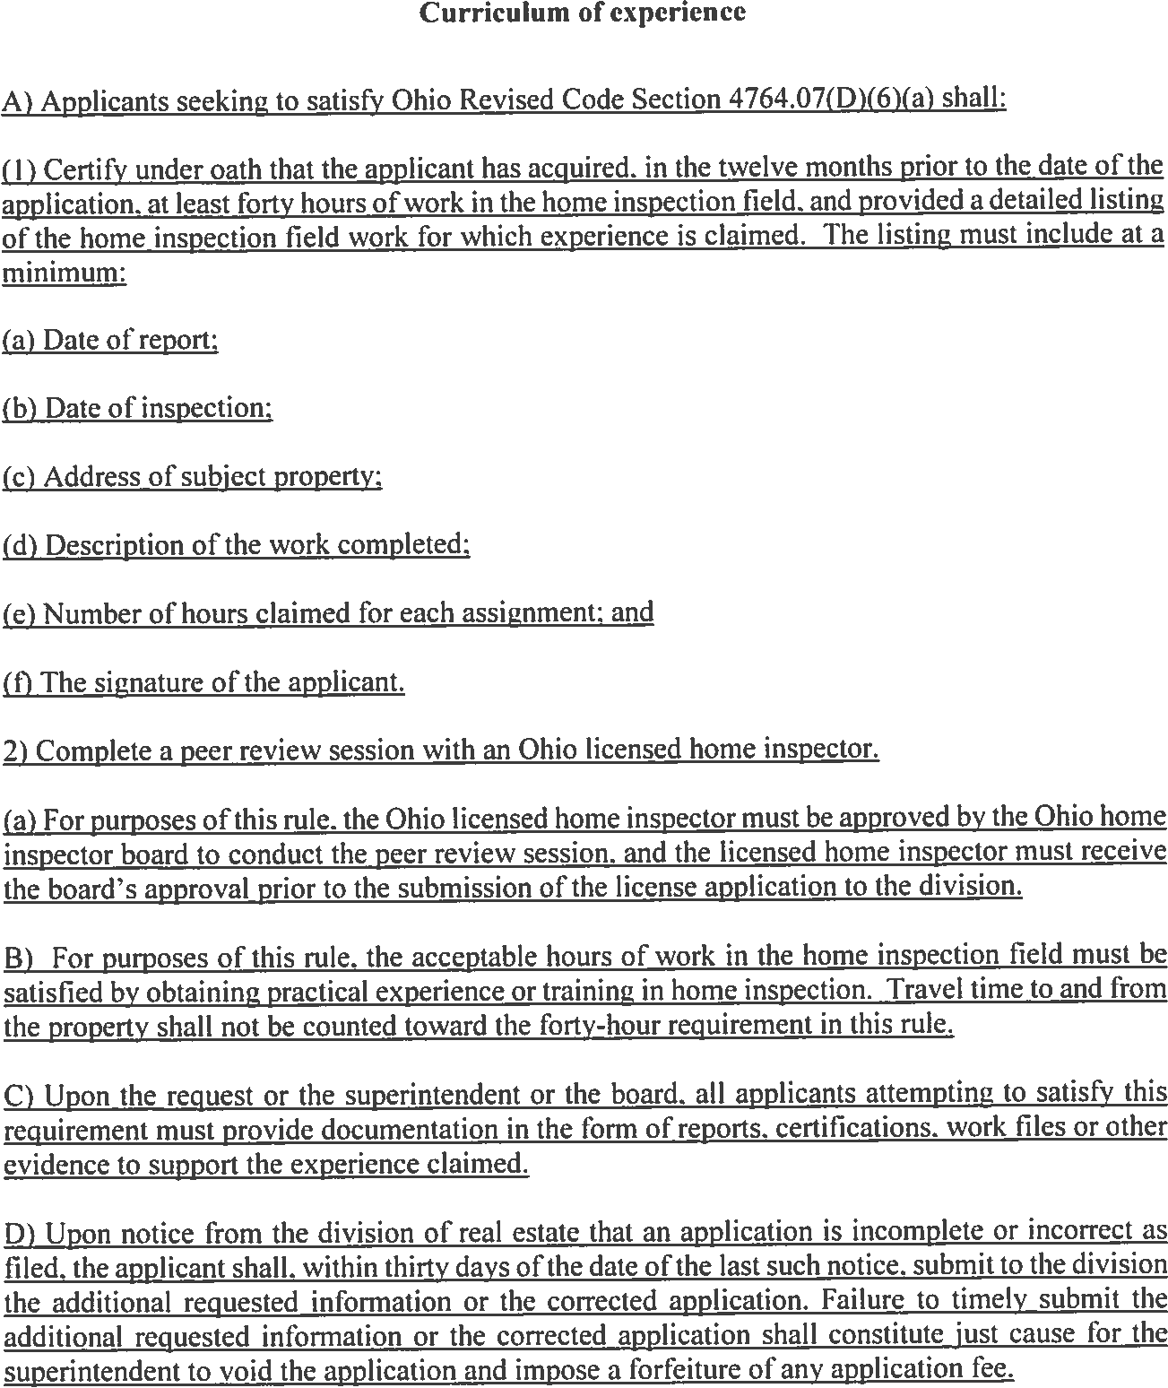
Delete in its entirety.
Re-write.

Parallel Inspection

(A) An acceptable parallel inspection in satisfaction of the requirement found in Ohio Revised Code Section 4764.07(D)(6)(b) shall consists of the following:
( 1) An applicant for a home inspector license is supervised by an Ohio licensed home inspector while conducting a home inspection for the licensed home inspector's client.
  - The home inspection must be an on-site inspection of a residential property.
  - Following the inspection. the applicant produces a written home inspector report that is reviewed by the Ohio licensed home inspector.
  - The licensed home inspector must review. analyze. correct if necessary and return the report to the applicant within 10 calendar days of receipt of the applicant's report.
  - The licensed home inspector must provide guidance to the applicant regarding the inspection process and the report writing process. Guidance includes instruction regarding the standards of practice and code of ethics adopted by the Ohio home inspector board.
  - The Ohio licensed home inspector may only supervise a maximum of two applicants who are. at the same time for the same property. inspecting and preparing a home inspection report for parallel inspection experience.

(8) An Ohio licensed home inspector supervising an applicant for this rule shall maintain an active Ohio home inspector license at the time of the parallel inspection occurs. and the Ohio licensed home inspector shall not be the subject to any home inspector discipline issued in the three years prior to the date of the parallel inspection.

- The applicant shall not perform any home inspections for compensation or other valuable consideration during the parallel inspection period.

- Satisfaction of this rule requires the completion of a parallel inspection affidavit signed by the applicant and by the Ohio licensed home inspector supervising the applicant. The affidavit shall also include a list of the properties inspected by the applicant. Upon request of the superintendent or the board. the applicant shall make available copies of reports. work files or other evidence to support the parallel inspection claimed.

- Upon notice from the division of real estate that an application is incomplete or incorrect as filed. the applicant shall. within thirty days of the date of the last such notice. submit to the division the additional requested information or the corrected application. Failure to timely submit the additional requested information or the corrected application shall constitute just cause for the superintendent to void the application and impose a forfeiture of any application fee.


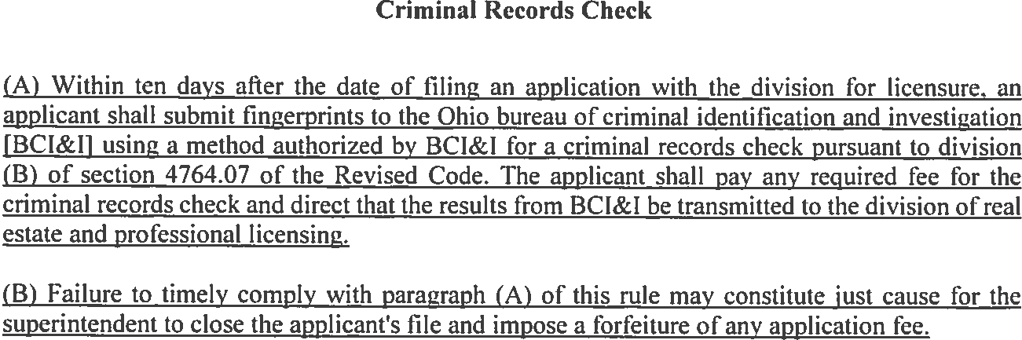


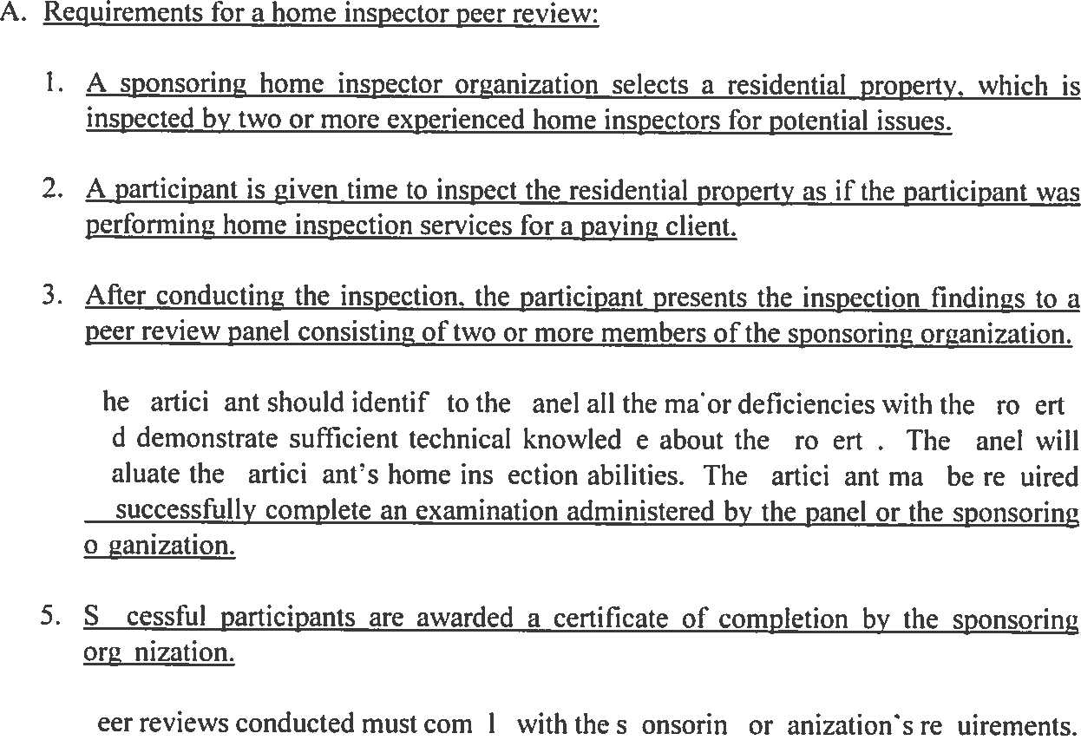
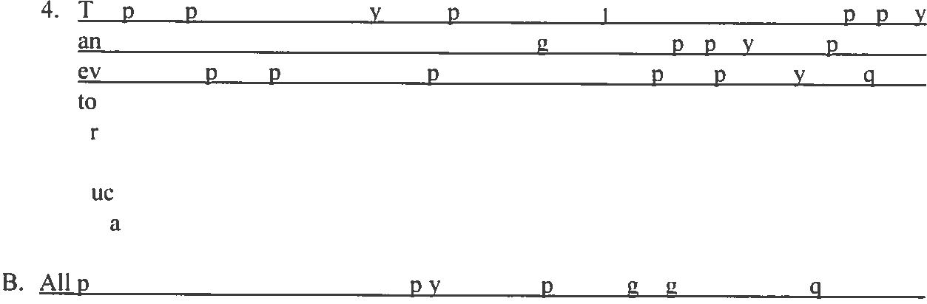
Delete in its entirety and re-write


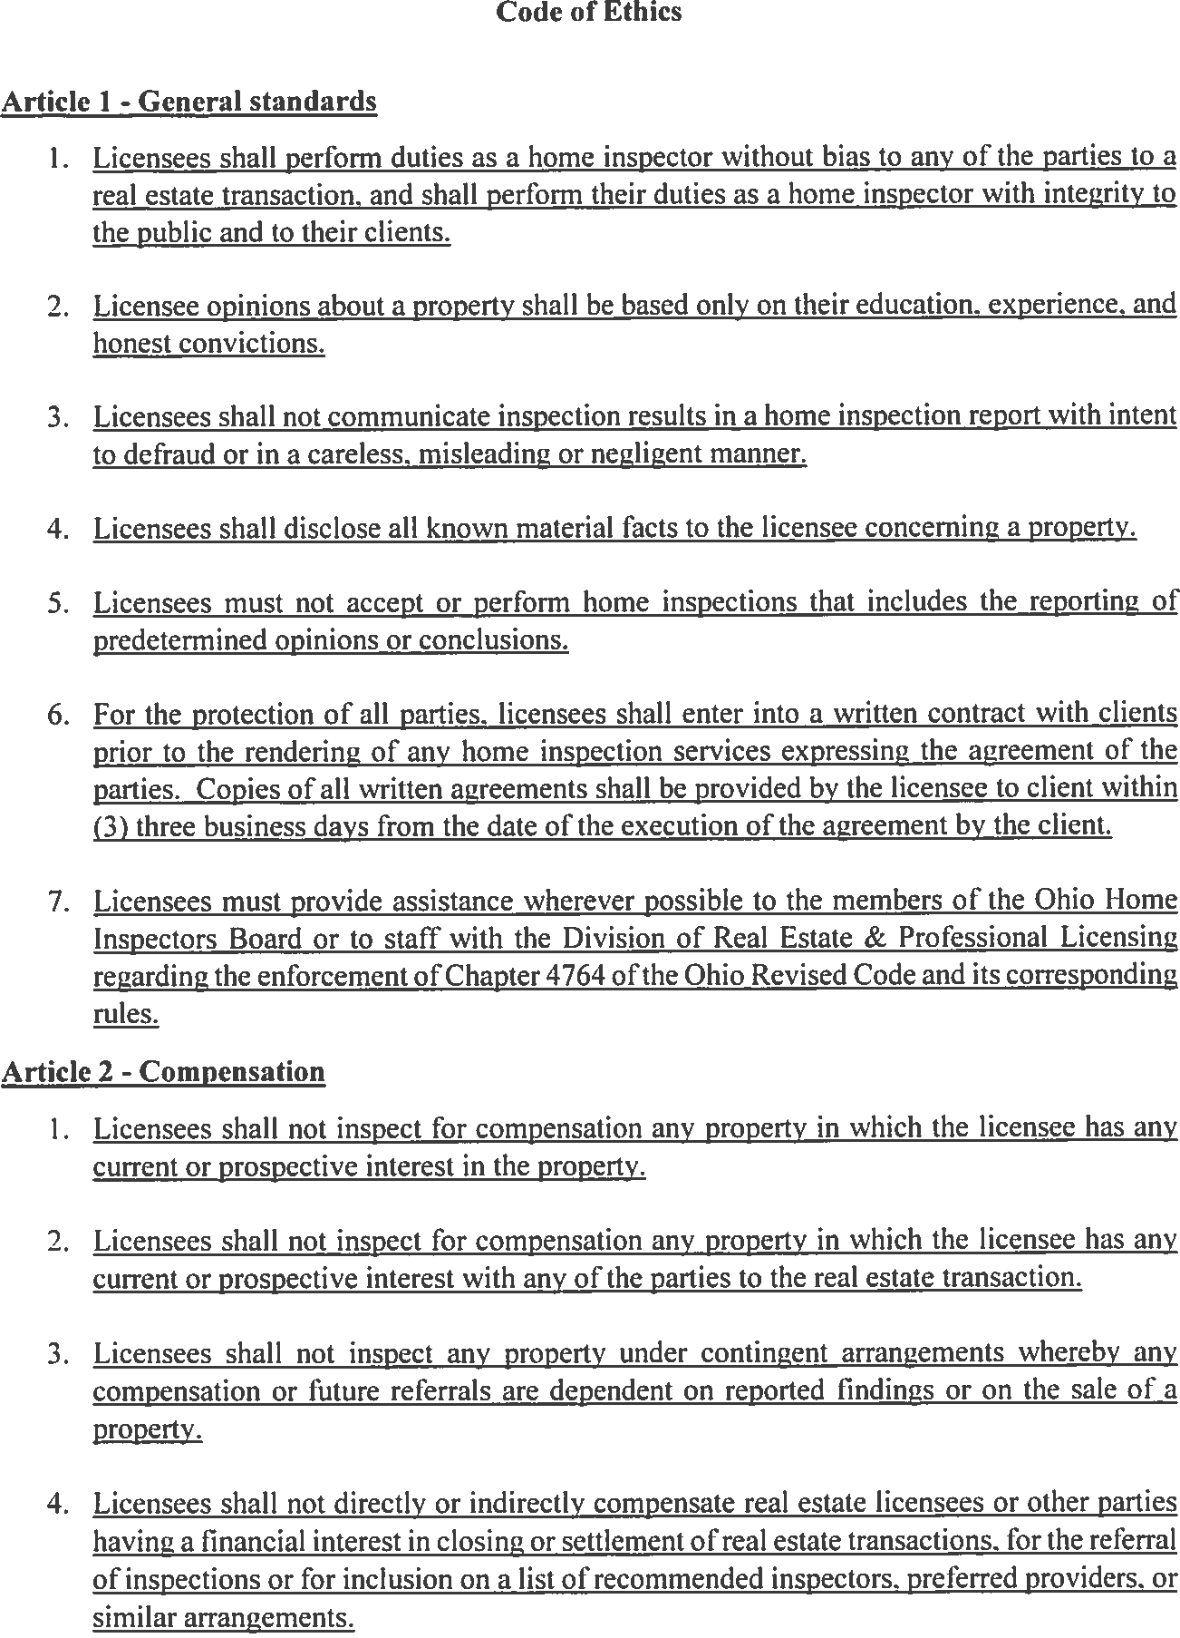
training


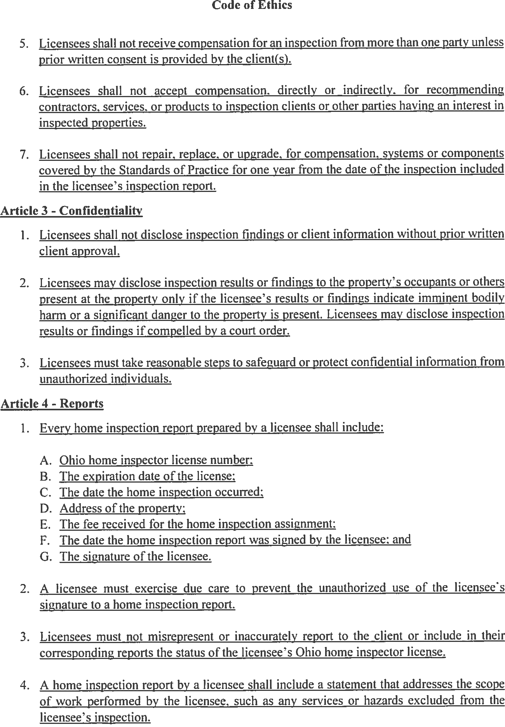
Electronic reports may not allow the signature.
shall


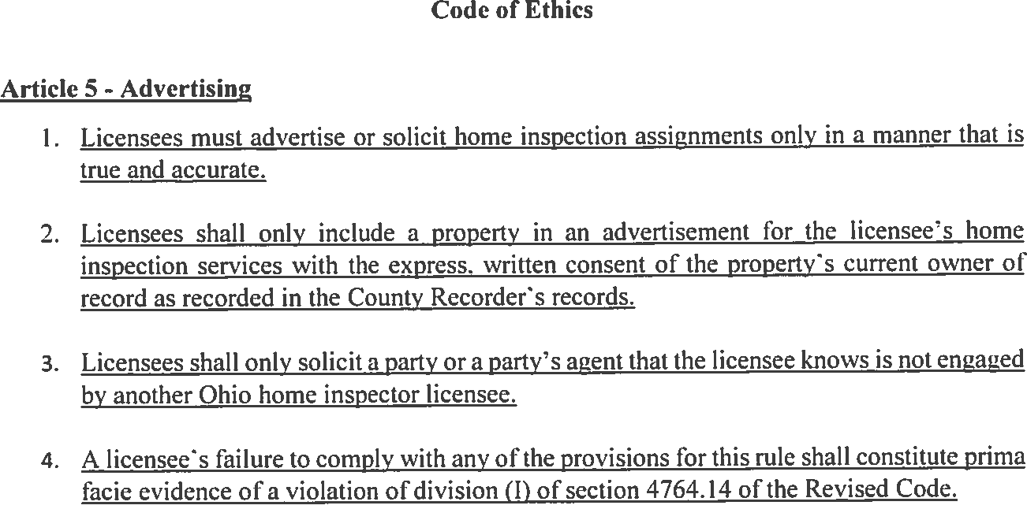
client


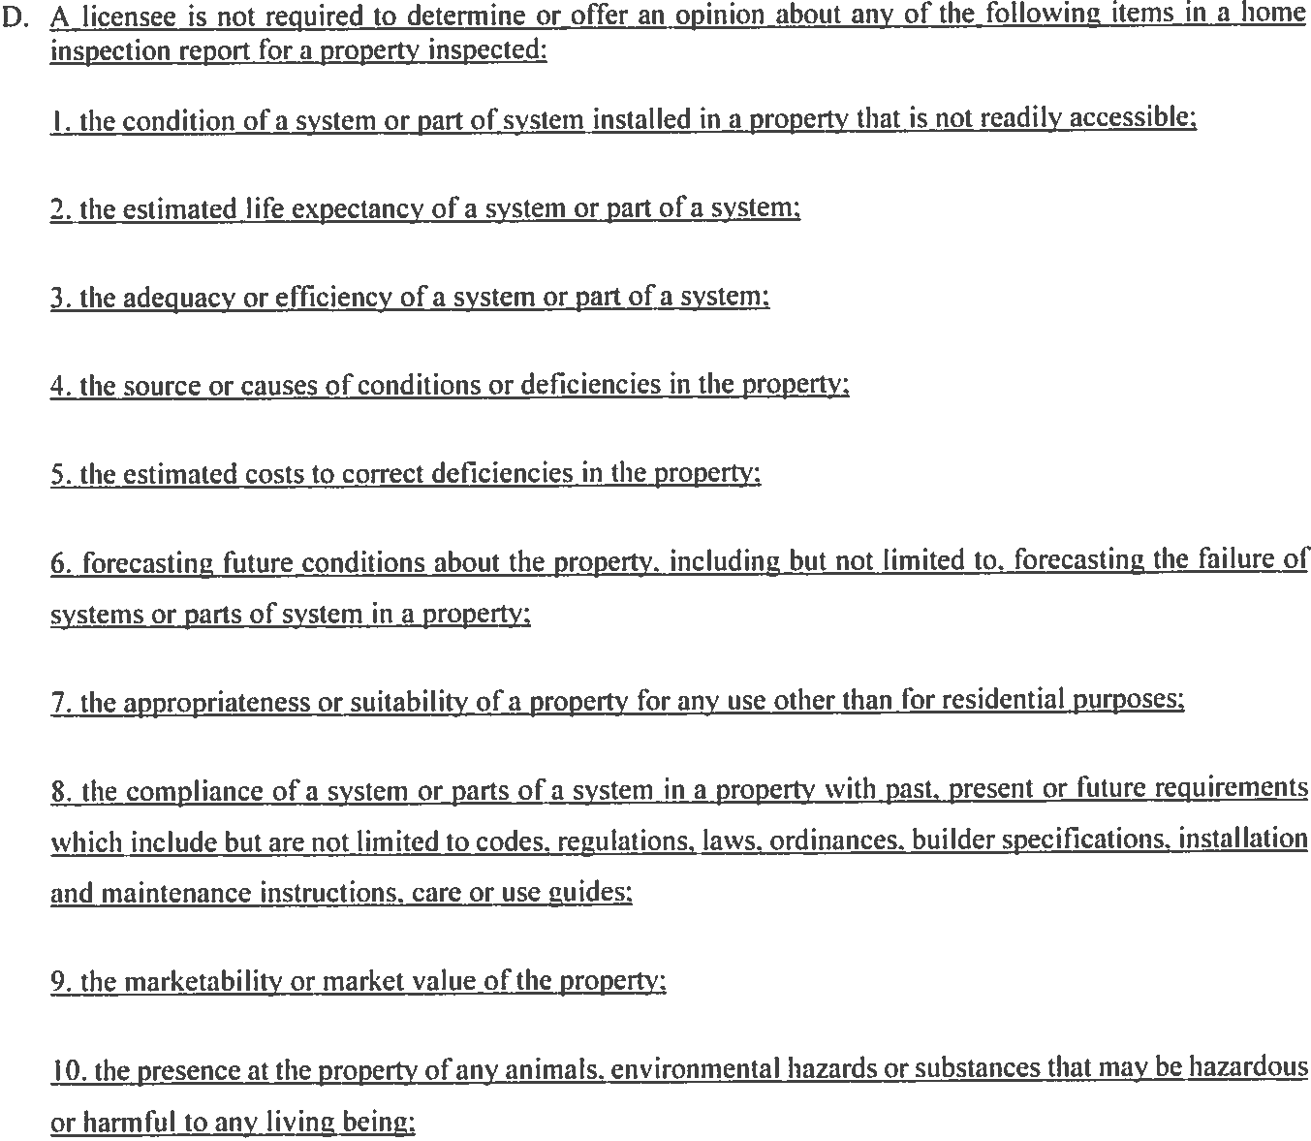
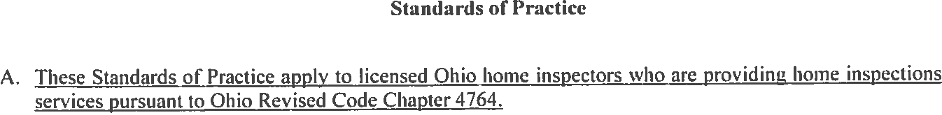
SEE E below


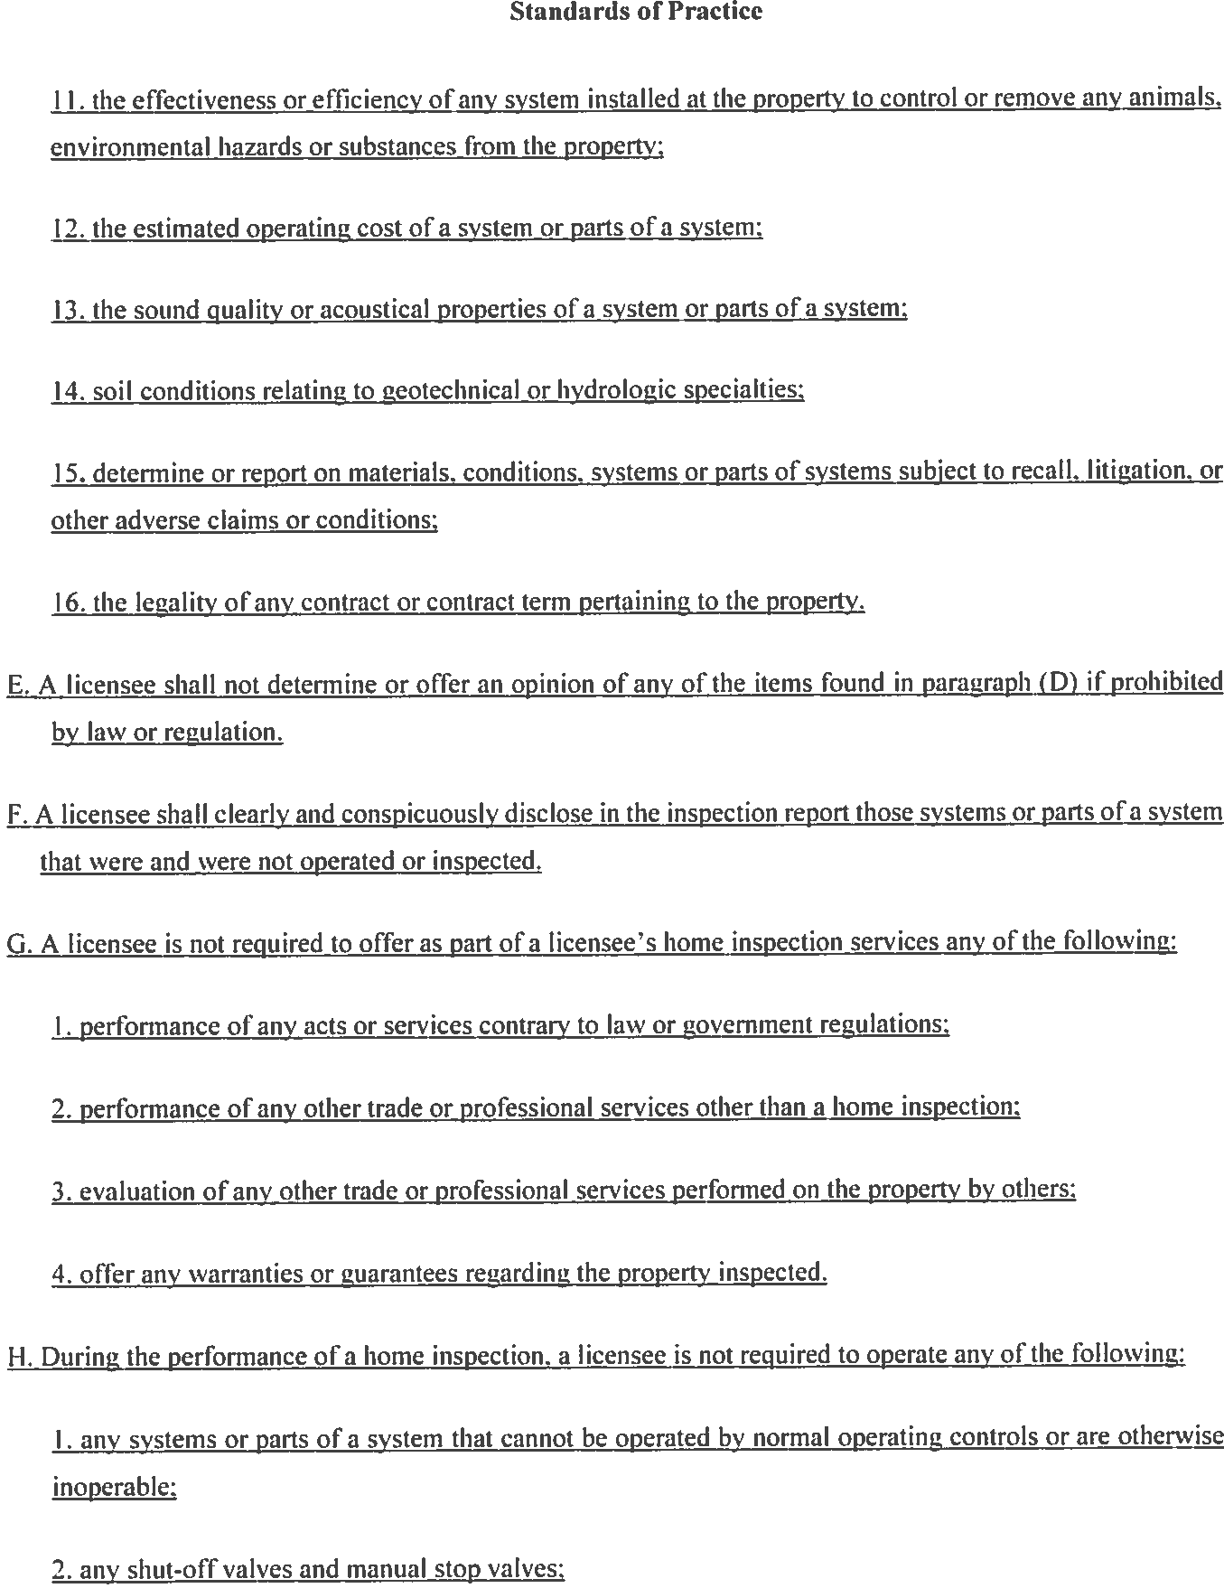
R.C. 3783 – NFPA 70 - NFPA 70E – OSHA 29 CFR Subpart S 1910.301-399


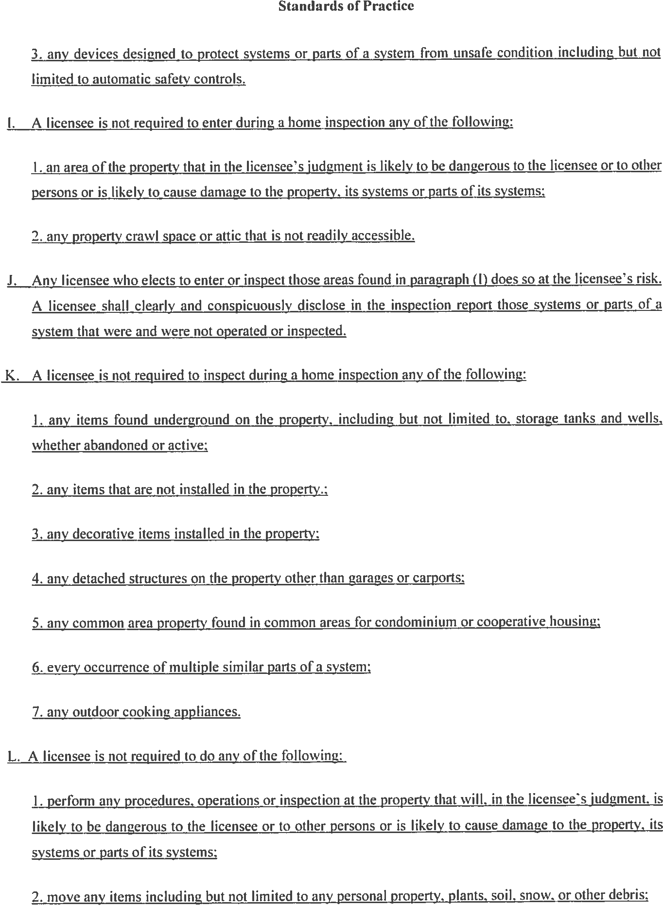


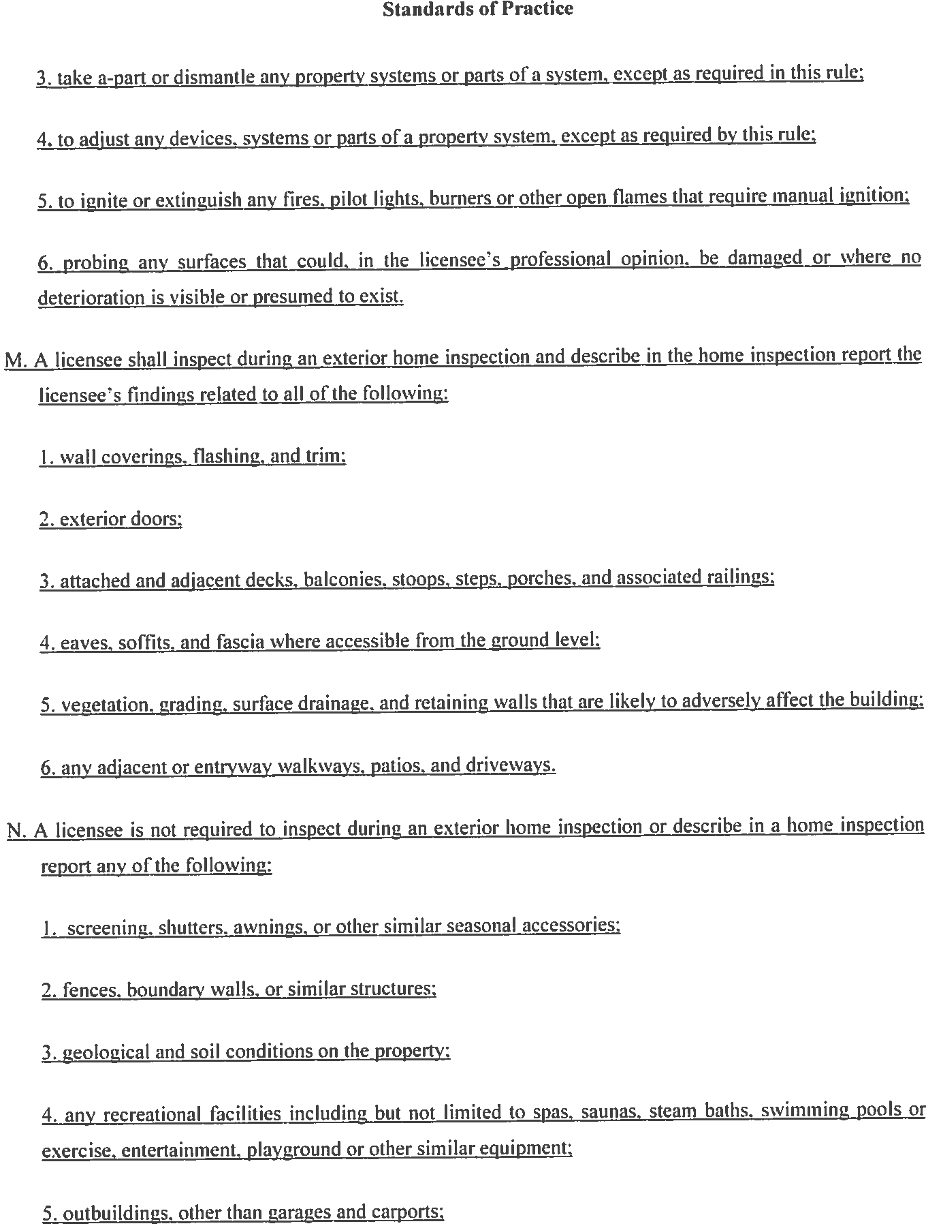


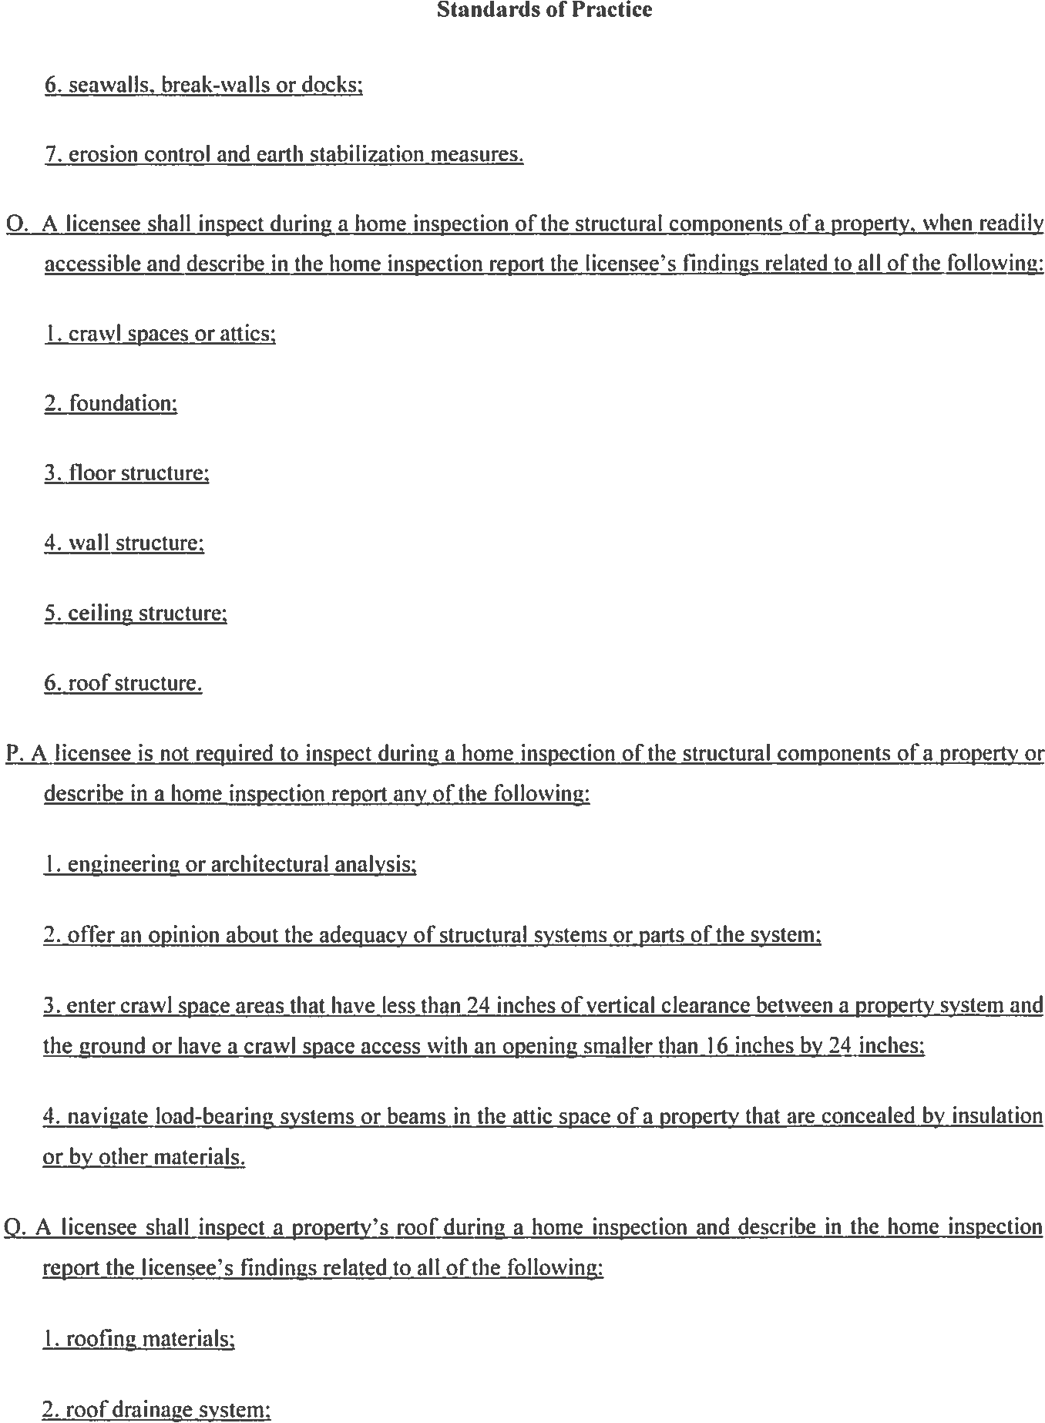


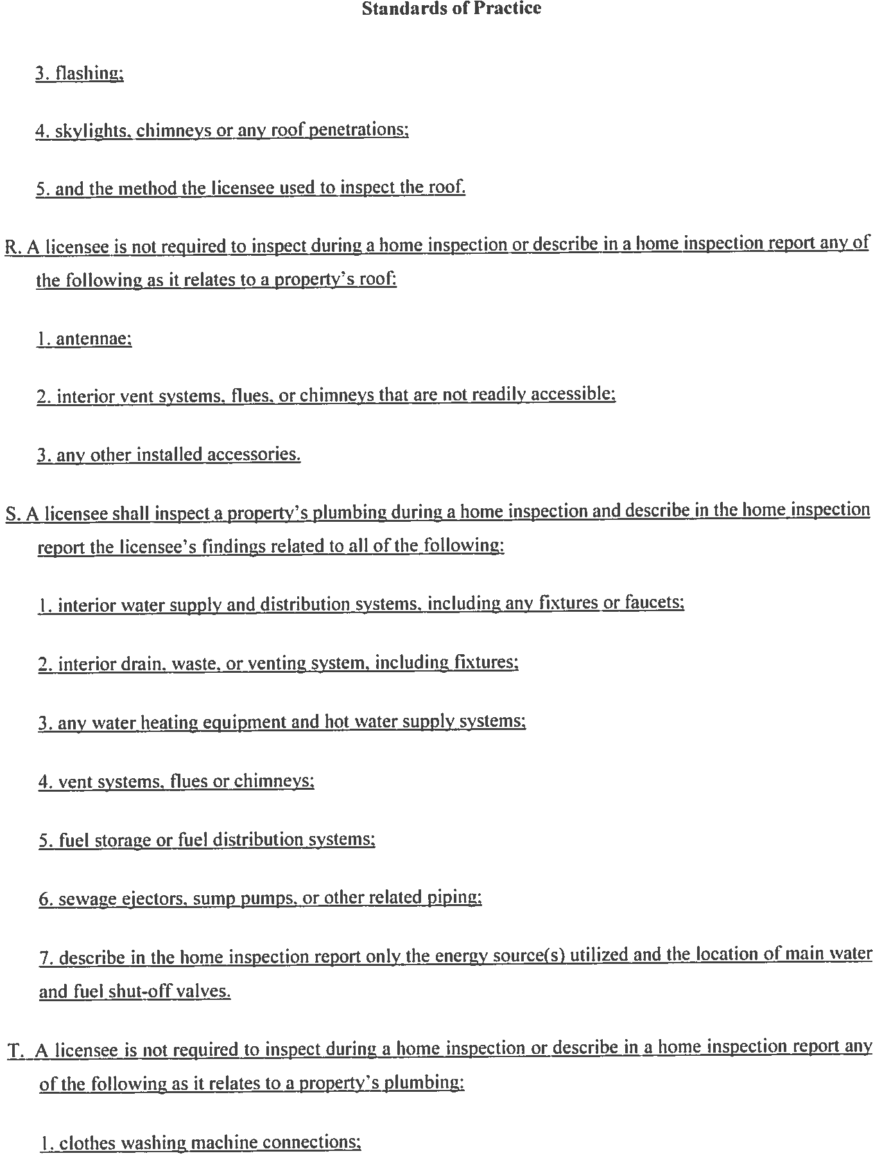


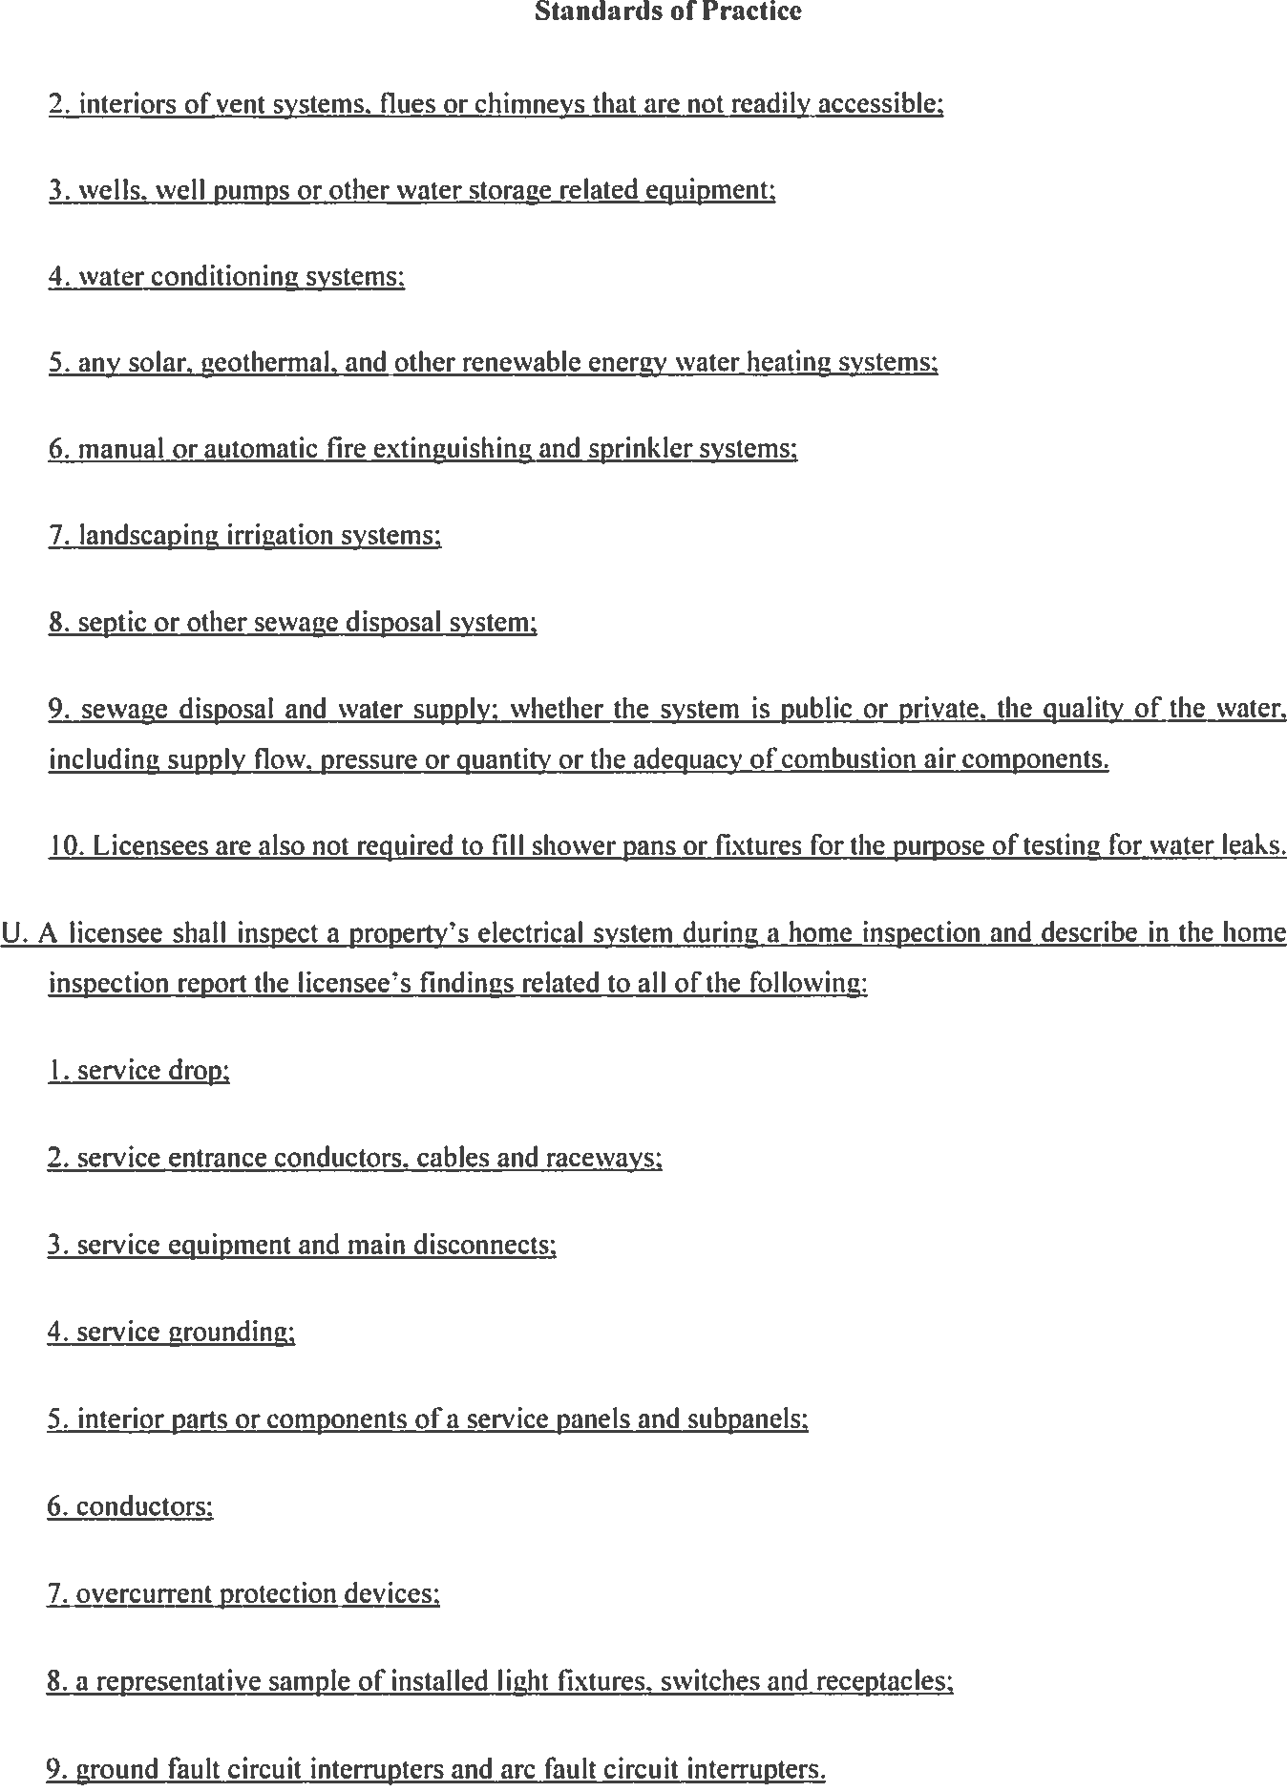
NOTE: readily accessible needs to be included to be consistent with other sections of the standards of practice.
the readily accessible components of the
See E above
(4)
(6)
(5)

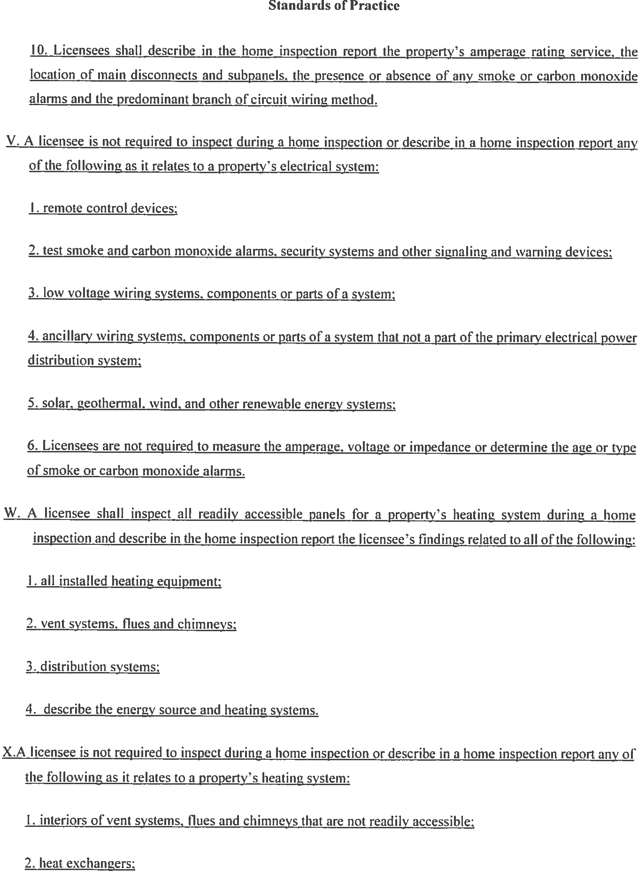
of the
(7)
(g)


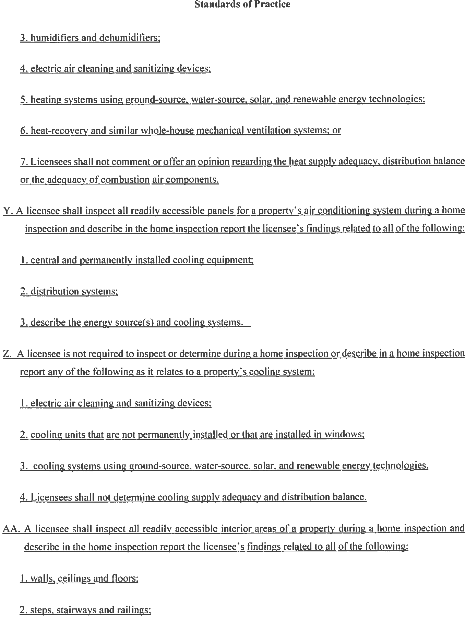


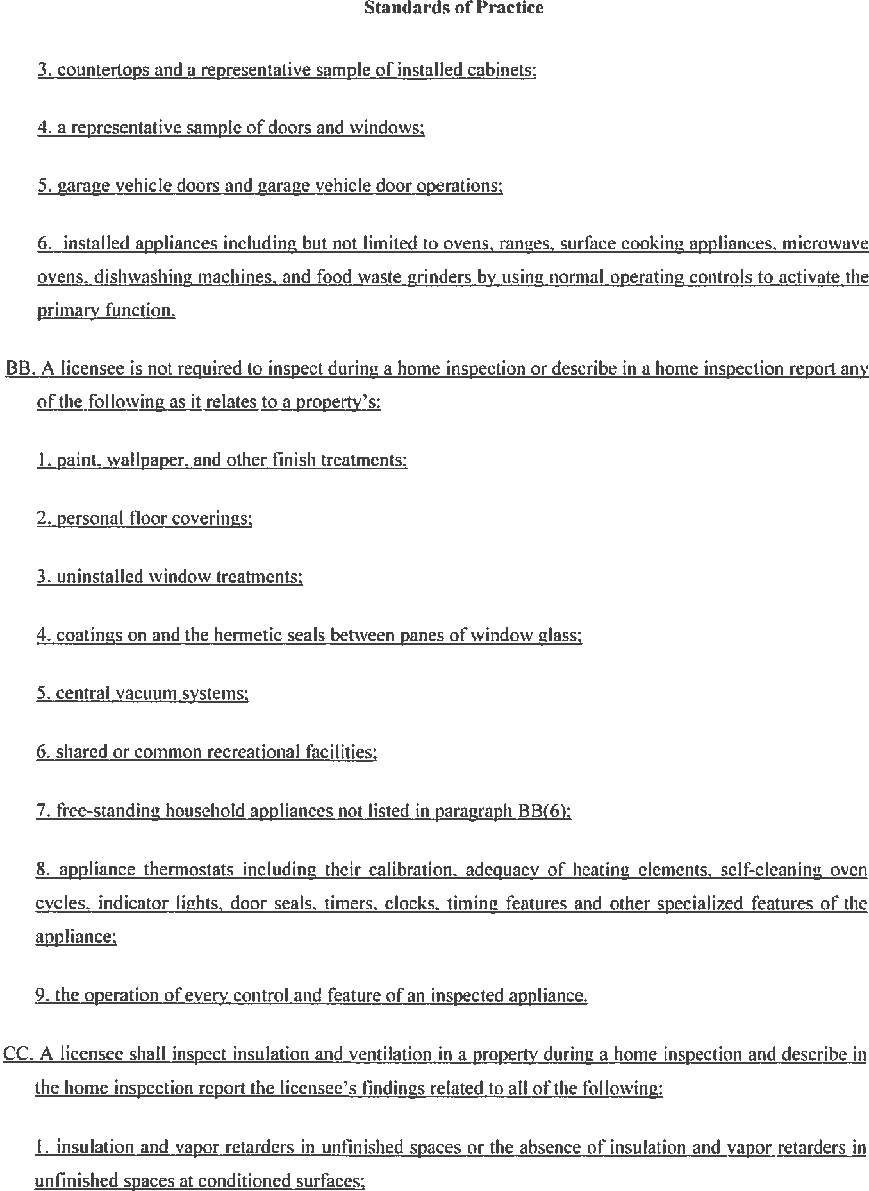


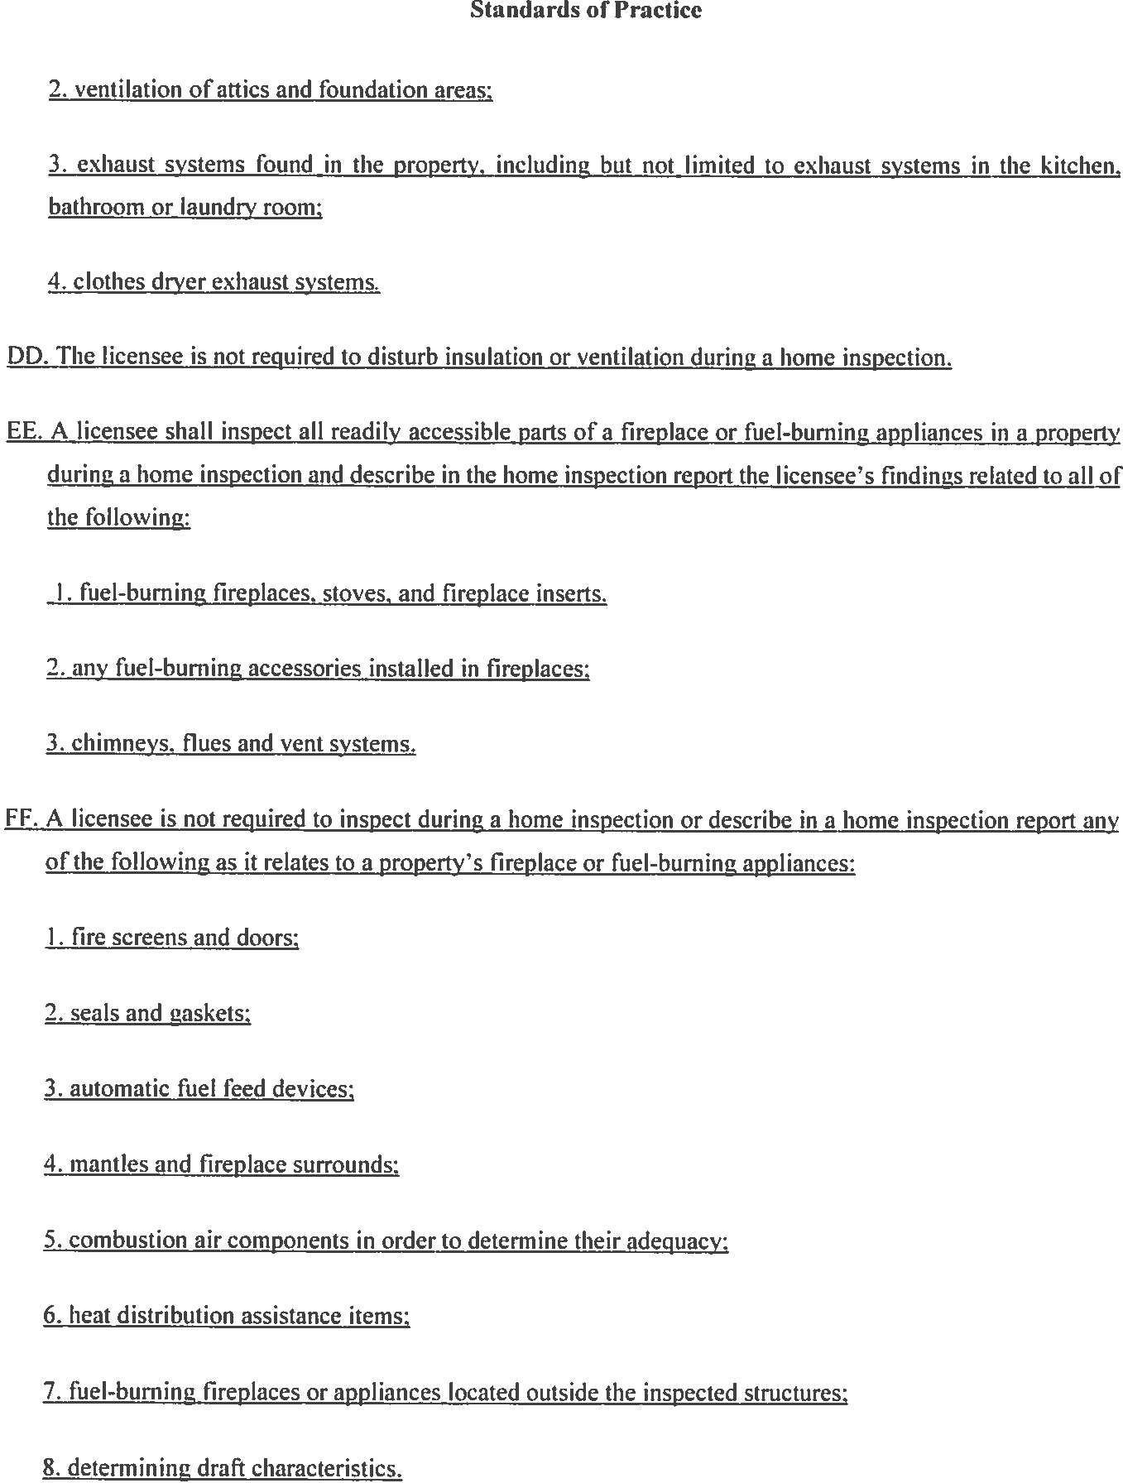

Re-write EE & FF

