4764.01 Definitions.
As used in this chapter:
(C) "Home inspection" means the process by which a home inspector conducts a visual examination of the readily accessible components of a residential building for a client.

(G) "Readily accessible" means available for visual inspection without requiring a person to move or dismantle personal property, take destructive measures, or take any other action that will involve risk to a person or to the property.

Chapter 4101:8-2 Definitions

4101:8-2-01 [Effective until 7/1/2019] Definitions.
SECTION 201 GENERAL
201.1 Scope. Unless otherwise expressly stated, the following words and terms shall, for the purposes of this code, have the meanings indicated in this chapter.
201.2 Interchangeability. Words used in the present tense include the future; words in the masculine gender include the feminine and neuter; the singular number includes the plural and the plural, the singular.
201.3 Terms defined in other codes. Where terms are not defined in this code such terms shall have meanings ascribed to them in other code s adopted and referenced by the Board of Building Standards.
201.4 Terms not defined. Where terms are not defined through the methods authorized by this section, such terms shall have ordinarily accepted meanings such as the context implies.
SECTION 202 DEFINITIONS
ACCESSIBLE. Signifies access that requires the removal of an access panel or similar removable obstruction.
ACCESSIBLE, READILY. Signifies access without the necessity for removing a panel or similar obstruction.

4101:8-2-01 [Effective 7/1/2019] Definitions.
SECTION 201 GENERAL
201.1 Scope. Unless otherwise expressly stated, the following words and terms shall, for the purposes of this code, have the meanings indicated in this chapter.

201.2 Interchangeability. Words used in the present tense include the future; words in the masculine gender include the feminine and neuter; the singular number includes the plural and the plural, the singular.
201.3 Terms defined in other codes. Where terms are not defined in this code such terms shall have the meanings ascribed to them as in other codes adopted and referenced by the Board of Building Standards (the Board).
201.4 Terms not defined. Where terms are not defined through the methods authorized by this section, such terms shall have ordinarily accepted meanings such as the context implies.
SECTION 202 DEFINITIONS
ACCESSIBLE. Admitting close approach as a result of not being guarded by locked doors, elevation or other effective means (see "Readily accessible").
READILY ACCESSIBLE. Capable of being reached quickly for operation, renewal or inspection without requiring those to whom ready access is requisite to climb over or remove obstacles or to resort to portable ladders or access equipment (see "Accessible").
READY ACCESS (TO). That which enables a device, appliance or equipment to be directly reached, without requiring the removal or movement of any panel, door or similar obstruction.

Chapter 4101:8-34 Electrical

4101:8-34-01 Electrical.
SECTION 3401 ELECTRICAL
3401.1 Electrical. The provisions of the National Electrical Code, NFPA 70, shall be incorporated herein and shall govern the installation, testing and operation of the electrical systems of one-, two- and three-family dwellings and their accessory structures except for the following:
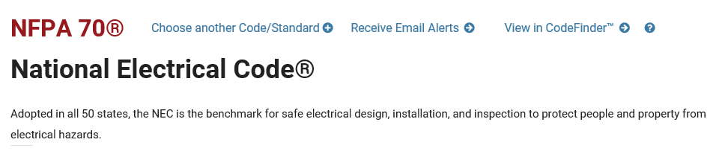
2017 Code Language:
Accessible, Readily (Readily Accessible). Capable of being reached quickly for operation, renewal, or inspections without requiring those to whom ready access is requisite to take actions such as to use tools (other than keys), to climb over or under, to remove obstacles, or to resort to portable ladders, and so forth. (CMP-1)

